Author 1 Name: Cameron A. Barnes; Author 2 Name: Tyler S. Ince-Ingram Author 3 Name: First M. Last;Author4 Name: First M. Last;Author5 Name: First M. Last
FAMU-FSU College of Engineering 2525 Pottsdamer St. Tallahassee, FL. 32310

Team 517: NASA-MSFC-Transportation of Large Loads on Lunar Surface

9/8/2022

Abstract
The abstract is a concise statement of the significant contents of your project. The abstract should be one paragraph of between 150 and 500 words. The abstract is not indents.

Keywords: list 3 to 5 keywords that describe your project.

Disclaimer
Your sponsor may require a disclaimer on the report. Especially if it is a government sponsored project or confidential project. If a disclaimer is not required delete this section.

Acknowledgement
These remarks thanks those that helped you complete your senior design project. Especially those who have sponsored the project, provided mentorship advice, and materials. 4
- Paragraph 1 thank sponsor!
- Paragraph 2 thank advisors.
- Paragraph 3 thank those that provided you materials and resources.
- Paragraph 4 thank anyone else who helped you.

Table of Contents
Abstract ii
Disclaimer iii
Acknowledgement iv
List of Tables viii
List of Figures ix
Notation x
Chapter One: EML 4551C 1
1.1 Project Scope 1
1.1.1 Project Description 1
1.1.2 Key Goals 1
1.1.3 Markets 2
1.1.4 Assumptions 2
1.1.5 Stakeholders 3
1.2 Customer Needs 3
1.2.1 Investigating Needs 3
1.2.2 Explanation of Results 6
1.3 Functional Decomposition 8
1.3.1 Introduction 8
1.3.2 Data Generation and Hierarchy Intro 8
1.3.3 Hierarchy Chart Explanation 9
1.3.4 Connection to Systems 11
1.3.5 Cross Reference Table 12
1.3.6 Smart Integration 12
1.3.7 Actions and Outcomes 14
1.3.8 Function Resolution 15
1.4 Target Summary 16
1.5 Concept Generation 16
Concept 1. 16
Concept 2. 16
Concept 3. 16
Concept 4. 16
Concept n+1. 16
1.6 Concept Selection 17
1.8 Spring Project Plan 17
Chapter Two: EML 4552C 18
2.1 Spring Plan 18
Project Plan. 18
Build Plan. 18
Appendices 19
Appendix A: Code of Conduct 21
Contacting Dr. McConomy 23
Statement of Understanding 24
Appendix B: Functional Decomposition 3
Appendix C: Target Catalog 4
Appendix A: APA Headings (delete) 4
Heading 1 is Centered, Boldface, Uppercase and Lowercase Heading 4
Heading 2 is Flush Left, Boldface, Uppercase and Lowercase Heading 4
Heading 3 is indented, boldface lowercase paragraph heading ending with a period. 4
Appendix B Figures and Tables (delete) 5
Flush Left, Boldface, Uppercase and Lowercase 6
Appendix C: 7
Appendix D: Work Breakdown Structure 8
References 10

List of Tables
Table 1 The Word Table and the Table Number are Normal Font and Flush Left. The Caption is Flush Left, Italicized, Uppercase and Lowercase 10

List of Figures
Figure 1. Flush left, normal font settings, sentence case, and ends with a period. 9

Notation
A17 | Steering Column Angle
A27 | Pan Angle
A40 | Back Angle
A42 | Hip Angle
AAA | American Automobile Association
AARP | American Association of Retired Persons
AHP | Accelerator Heel Point
ANOVA | Analysis of Variance
AOTA | American Occupational Therapy Association
ASA | American Society on Aging
BA | Back Angle
BOF | Ball of Foot
BOFRP | Ball of Foot Reference Point
CAD | Computer Aided Design
CDC | Centers for Disease Control and Prevention
CU-ICAR | Clemson University - International Center for Automotive Research
DDI | Driver Death per Involvement Ratio
DIT | Driver Involvement per Vehicle Mile Traveled
Difference | Difference between the calculated and measured BOFRP to H-point
DRR | Death Rate Ratio
DRS | Driving Rehabilitation Specialist
EMM | Estimated Marginal Means
FARS | Fatality Analysis Reporting System
FMVSS | Federal Motor Vehicle Safety Standard
GES | General Estimates System
GHS | Greenville Health System
H13 | Steering Wheel Thigh Clearance
H17 | Wheel Center to Heel Pont
H30 | H-point to accelerator heel point
HPD | H-point Design Tool
HPM | H-point Machine
HPM-II | H-point Machine II
HT | H-point Travel
HX | H-point to Accelerator Heel Point
HZ | H-point to Accelerator Heel Point
IIHS | Insurance Institute for Highway Safety
L6 | BFRP to Steering Wheel Center

Chapter One: EML 4551C

Project Scope

1.1.1 Project Description
The objective of this project is to design a device that will be capable of transporting a 205 lb load on the surface of the moon from the landing site to a habitation area to support NASA’s goal of lunar sustainability, development, and expansion within the Artemis Mission.

1.1.2 Key Goals
In this project the Lunar Transport team aims to produce a design or system with a working protype to demonstrate specific solutions designed to transport loads over the lunar terrain. Key characteristics of the design should include being robust and light weight. Reduction in weight translates to lower costs of delivery to the moon, therefore, with the cost of transport per mission being about $2.0 million per kilogram, the design must be cost effective. The lifecycle of the design is of particular concern, considering the harsh conditions of the moon and their degrading effects on mechanical systems. The ideal design should last up to a year with cyclical maintenance of equipment. The persistence and damaging effects of abrasive lunar dust calls for a robust design which protects mechanisms with a specific dust mitigation solution designed by the team. Considering the mass of loads needed to be carried, the team decided to design with a factor of safety of 6 which was defined by the final mechanism being able to lift 1.4 metric tons .. All NASA and United States safety standards are met as a baseline of safety for the operating crew and the environment.

1.1.3 Markets
Our sole primary market for this project will be NASA who will be serving as the project sponsor and main entity that will put the product to use. Secondary markets would include the likes of SpaceX, Blue Origin, Lockheed Martin, and Boeing, all of which are organizations who have an interest in space and who could make use of our product.

1.1.4 Assumptions
Throughout this project there will be assumptions made to focus the team’s efforts into the necessary areas for our project. It is assumed that the payload will have a maximum mass of 1.4 metric tons on Earth and 8.4 metric tons on the Moon. It is assumed the device or system will be built with loose tolerances. Additionally, it is assumed it shall survive the lunar night, but there is no requirement for it to transport loads during that time. It is assumed that the landing site will be close to the designated habitat area, and the device will only be required to transport loads up to 1 kilometer (km). It is assumed the device will be able to withstand temperatures ranging between 140 K (~133.1℃) and 400 K (~126.8℃). It is also assumed that the materials purchased will be budget-friendly and that would be substituted when needed in a space mission application. The habitation area is expected to be a generally flat ground area with pothole-like craters being the exception. Dust mitigation is assumed to be a necessary future work design component which is beyond the scope of our project. Automation systems will also fall into this category.

1.1.5 Stakeholders
Our main stakeholder would be NASA as their organization is sponsoring the device creation, specifically, our liaisons Arthur Werkheiser and Michael Zanetti. Dr. McConomy would act as a stakeholder as he has contributed time and effort to ensuring that the team possesses the necessary skills to communicate and collaborate with other stakeholders, our team, and project advisors. Also, Dr. Oates would be our faculty advisor and act as a point of contact for project advice and guidance.

Customer Needs

1.2.1 Investigating Needs
NASA has partnered with the FAMU-FSU College of Engineering to develop a device capable of transporting heavy loads on the lunar surface. NASA put the team in contact with Arthur Werkheiser, Deputy Branch Chief at Marshall Space Flight Center (MSFC), who is acting as both a team advisor and liaison, along with Dr. Michael Zanetti, Lunar Surface Expert at MSFC, who is acting as the point of contact regarding topics related to the lunar surface. During a meeting held on September 26th at 2:00pm EST, the team conducted a customer interview with Werkheiser over Microsoft Teams. The team left the questions open-ended, as not to steer the conversion or answers. His responses to the set of questions, along with the interpreted needs are displayed in Table 1.
The responses to the questions helped the team determine what aspects our efforts will focus on. Our questions focused primarily on payload size, type of cargo, and specific forms of operations which provide critical constraints to the future design. From the customer statements, an interpreted need for each statement was formulated. The interpreted needs describe the underlying requirements needed to transition into the next phases of the project and understand device requirements. The sponsor statements outlined the monetary constraints of the project due to the high cost of transporting a single kilogram of mass from the earth to moon. The available payload bay size on the rockets traveling with the Artemis program also constrains the size of the final design and its capabilities. Additionally, asking questions which revealed these natural constraints was an important part of this section. The team asked questions to work against scope creep, by minimizing over development of unnecessary aspects with regards to our problem statement.

Table 1. Customer Interview
Question asked | Customer Statement | Interpreted Need
What is the purpose behind developing a form of heavy lunar transport? | “Having a landing site away from the habitation area is a necessity. Need a device that goes back and forth from habitation area and landing site. Also, could help with scientific exploration.” | The device is designed for travel between a habitation area and landing site. A power storage system is needed to sustain medium range travel with varying loads.
Does the device need to lift anything or is it just transporting objects? | “Yes, it should at least assist in lifting. Hard to grip things in space so it should aid the astronauts in some capacity. “ | The device is equipped with some form of lift to assist in collection materials/resources from the lunar surface. Device needs to focus on transporting heavy loads.
What type of cargo will the device be lifting? | “Habitation Cargo, goods from rocket, fuel for rocket, and people.” | The device is adaptable to multiple forms of payloads. Rocket payloads and habitation equipment are the routine target loads.
What is the payload size/weight? What is considered ‘heavy’ on the moon? | “A metric ton (2200 lbs) -on Earth” | The device supports a payload weight of 1 metric ton.
Does the speed of the device matter? / At what speed does the device operate? | “Safety comes first, slower is safer. Deals with humans with limited air pack so an emergency mode would be nice. Cover a kilometer in 10 min at least.” | The device is capable of reaching speeds of 6 km/h.
Preferred form of operation autonomous, human operated, remote controlled? | “In reality it should be autonomous but for the purposes of your project remote controlled or human operated. Could do some type of line following also.” | The device has autonomous pathing in most situations. Can be manually controlled if a human operator is present.
What is the budget? | “Around $2,000.” | The budget of the project is $2000 or less.
What is the device weight limit? | “Safety factor 1.4, payload is 1 metric ton, calculate this value.” | The device weighs less than 1.4 metric tons.
Define Rocket Size Constraints. | “The design should fit within the diameter of the SpaceX Starship (9 meters) minus 10% for packaging.” | The device is designed within the rocket constraints of 7.5 m to 8 m in length.
What would you consider a successful project? | “An earth-bound prototype which is able to be tested and evaluated. “ | The final device is a scaled earth-bound hardware-based prototype with functional testing applicable at the Marshall Space Flight Center regolith field.

1.2.2 Explanation of Results
From these interpretations, we determined the necessary areas of focus for our device as we transition into the next phases of the project. The design primarily focusing on transporting heavy loads will require multiple sub-system solutions to deal with usability and survivability. Questions up to this point have been guided toward finding a medium between complexity and robustness for successful transportation and lifecycle maximization in the harsh lunar climate. Specifically, the team will need to design a packaging system or containment system to house the payloads. The customer is concerned about the variability of size and shape of payloads rather than focusing on optimizing the load bearing capacity. Considering the relative maximum weight of the payloads the design will need an assistive mechanism facilitating human operators when they attempt to load the device. The customer outlined a specified set of constraints stemming from the weight of the design and payloads. The power system needs to be designed to travel long distances while being adaptable based on the required exertion of the device. An energy feedback system that informs the operators based on the amount or type of loading is subsequently necessary.
With respect to high safety standards and preventing hazardous incidents the movement speed of the device can be relatively low, calculated at around 4-8 km/hour. The final concept is ideally fully autonomous when traversing the lunar surface using specified preprogrammed routes to move payloads. The customer prefers autonomy so lunar operators won’t need to waste supplies such as oxygen for transportation tasks. The assumption was made that for the scope of this project autonomy is necessary but part of another project, this project will only address the vehicle design and functionality.
At the conclusion of our project, the customer desires to have a roughly functional prototype. This prototype should focus on the transportation component specifically and any other subsystems such as power, lift, and dust mitigation, would be favorable but not required. The design should favor inexpensive materials rather than the quality that would be expected on the lunar surface.

1.3 Functional Decomposition

1.3.1 Introduction
Functional Decomposition is a problem-solving method utilized to reduce the complexity of an entire system by breaking it down into simpler components. This process takes the problem statement and customer needs and translates it to functional performance qualifications for the device. These are necessary actions the components need to complete for the device to be considered successful.

1.3.2 Data Generation and Hierarchy Intro
In our functional decomposition, our product, the Hermes vehicle, was analyzed and broken down into its simplest functions and actions shown in Figure 1 by questioning what tasks the system will have to perform. Hermes was broken down into four systems proceeding into 12 subsystems. The visual representation of our functional decomposition shown in figure 1 follows a tree hierarchy with the four main systems being survivability, power, activation, structural design.

Figure 1. Hierarchy Chart
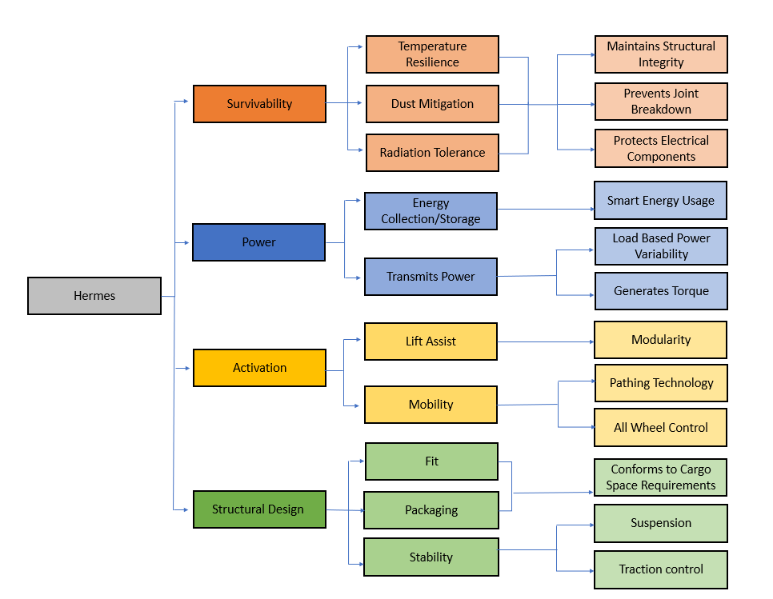

1.3.3 Hierarchy Chart Explanation
The team generated a functional decomposition of the Hermes transport vehicle. Considering the environmental consequences imposed by temperature, gravity, radiation, and dust on the moon were the main factors impacting the complexity of subsystems. The four main functional groups for the design are survivability, power, activation, and structural design. Survivability is of concern considering the prior lifecycle of past lunar rovers only reaching up to 24 hours of active duty. With respect to this category the team wants to mitigate dust accumulation, damage from radiation, and temperature strain. Increasing the lifecycle of the vehicle will be key to successful cost-effective missions. The longer the design survives the lower the cost of operation per day. The extremely low lunar temperatures during the 14-earth day lunar night are challenging in terms of controlling material temperature strain. One of the primary functions of the addressed by the design will be to reduce sensitive interior component breakdown due to prolonged cold exposure.
Onboard power systems for Hermes will be complex with a customer designated need for renewable energy sources. The power system will be multi-functional with the design requiring high torque output for heavy loads. The focus of the power system will be the storage of energy and the adaptable control system needed to manage power output. The loading of the device is presumably extreme therefore the power system will need to make active output corrections based on the demand of the workload. The longevity of the power source is directly correlated to the working range of the design and its overall lifecycle.
Activation handles the mobility of both the vehicle transportation and lifting assistance. The lifting mechanism should be modular to adapt to a variety of payloads. Additionally, the overall device movement will rely heavily on the designed pathing technology and wheel control.
The structural design of Hermes is the most important system and was broken down into three objectives: fit, packaging, and stability. Fit is the need for the device design to handle many types of payloads this includes both people and general cargo. Additionally, the device packaging must be adaptable to the constraints of the rocket cargo area; this might include folding or compacting the vehicle during transport to the moon. The Hermes vehicle will require some commissioning to begin function, but this system should be around a 3 to 1 split between automated and manual assembly, this will be a requirement of the packaging system. Finally, Hermes should transport the load in a stable manner over the harsh terrain to avoid loss or damage to cargo. This will have to include some sort of wheel suspension and traction control.

1.3.4 Connection to Systems
Hermes has four major functions: survivability, power, activation, and structural design. Maintaining structural integrity, preventing joint breakdown, and protecting electrical components are important for the overall survivability on the moon. We decided that these are key components when doing the following: attempting to mitigate dust when regolith is tossed around causing joint failure and degradation, resisting temperatures preventing our material from cracking under extreme loads when exposed to extremely cold temperatures, and radiation resistance as it causes issues to arise with the electrical components due to the high amounts of radiation.
Our power system has an energy storage connected to a renewable energy source that needs to relate energy output to the amount of weight Hermes is carrying. It also needs to be able to adjust our torque when we have heavier or lighter loads. Hermes lift assist will have a lifting mechanism to help with loading cargo on and off its storage platform as well as having an automated line path technology that could guide itself when picking up that cargo. Hermes’s structural components require a big enough storage platform that can carry said cargo but small enough to fit in the transportation rocket. Hermes’s will also have a suspension system to counter regolith emission from wheels as well as help stabilize our cargo load. Due to the heavy layer of regolith Hermes will be driving through, it will also have a traction control system that will help it not deter from its lined path.

1.3.5 Cross Reference Table
The functional decomposition cross reference chart, Table 2, demonstrates how the functional systems of the device relate to one another. The four main systems are labelled as the columns of the matrix and the twelve sub-systems as the rows. An ‘X’ denotes if a sub-system function will directly affect one of the four main systems of the device.
Table 2. Cross-Functional Relationship Matrix
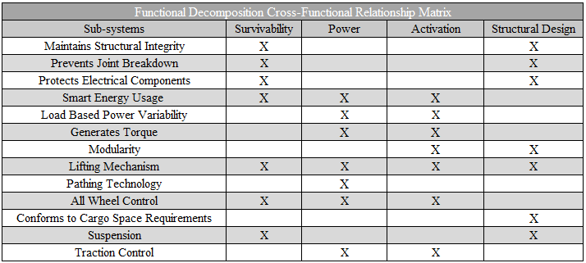

1.3.6 Smart Integration
Beginning with the first three functions each will require the use of two sub-systems: survivability and structural design. This is due to the survivability of the device and the structural design being codependent on each other for the survival of the harsh moon conditions. Smart energy usage requires the power and activation functions to provide both power and activation to the systems, while also requiring survivability to maintain operation even during the lunar night. Load based power variability and the generates torque system both require power and activation to be useful. Modularity will play a role in both the lift assist and the structural design of the vehicle, as various mechanisms will be needed depending on the cargo collected as well as the type of cargo being transported. The lifting mechanism requires all four subsystems both power and activation are required to use the mechanism, survivability is required because the lifting mechanism is required to last and operate every time while surviving the moon conditions. Lastly, structural design is required because the structure will have to be designed around the lift for stability. All wheel control uses survivability due to the steering and control of the device being necessary it also uses power and activation to operate. Suspension uses survivability as the suspension is necessary to stabilize the load and structural design because the design will have to be designed to fit the suspension. Traction control uses both the power and activation function to assist the vehicle in maintaining contact with the lunar surface when crossing uneven terrain.
Based on the scope and customer needs, the lunar transport vehicle should be a display of the various hardware solutions for cargo transport on the moon. In terms of a full-fledged conceptual design, control systems will be the main integration between components for this design. With regolith and dust being key concerns, a traction control system which systematically determines the minimum amount of torque and speed needed at each wheel to traverse the surface without lifting dust is a necessity. Smart energy consumption and alteration of output based on subjected load is a further subsystem. Finally, a control system which can navigate terrain without expending crew working hours is a actionable goal for the finalized design, this system will integrate the structure, power and activation systems.

1.3.7 Actions and Outcomes
In this project the main physical action to be performed by the designer is for a load of mass m, to be successfully transported from point A at x = 0 meters to point B which can be anywhere up to 1000 meters away as defined in our scope. The customer needs a device that can handle the workload necessary to support the manufacturing of structures on the moon as part of the Artemis space missions. The ideal packaging of a set of cargo is within uniform shaped containers. Hermes will be part of a multi-step process where the operator loads the vehicle using the lift assisting system, contains the cargo by physically securing it to the compartment, and traverses the desired route while creating as little regolith disturbance as possible. Within this three-section process Hermes will need to lift the load, stabilizing its center of mass during this off-center motion. Carrying one metric ton of material at a time is a key goal of the final design but with respect to lifting, the team expects loads up to a third of a ton at a time. The lift assist will, at a minimum, be responsible for facilitating the vertical movement.
With regards to the chassis of the design where the payload compartment(s) will be housed. A cargo securing system should be in place to minimize shifting, sloshing, or vibrations during transport. The main goal being the preventing of roll-over or cargo loss scenarios, again considering that minimal disturbance to the regolith is key. The vehicle body should be able to traverse flat but rough terrain where a vibration damping system should attenuate unwanted movement much like a traditional car’s suspension system.
Traversing the lunar terrain should be the most basic key task required of the final design. The vehicle should be equipped with several automating control systems which manage route pathing, obstacle detection, traction control, and intelligent energy usage. These controls systems should result in a physically smooth ride which doesn’t cause damage to the cargo. This customer need is supported by the velocity constraint, rides need to be safe and effective, speed can be low if routes are completed.

1.3.8 Function Resolution
At its most basic level, the device has four main categories. For survivability, the smallest components necessary would be shielding from radiation using material that would deflect radiation off, joint protection from dust mitigation, and using the right material and insulation so that the structure and integrity of Hermes could resist extreme cold. For power, our system has an energy storage as well as an energy source which will supply our motion. In this system we need a smart power system that does not waste energy. This system will have to turn on and off when necessary and adjust to weight so that more energy is conserved or needed. Our activation system will need strong structural support for our lifting system so that it can repeatedly do its job. Also, will have to have a strong structural wheel system so that it does not veer off path. Structural design needs to be highly stable by designing a system that would prevent roll over and loss of cargo. We will also have a size constraint so that it is small enough to fit in the rocket but big enough to have a strong structural component and cargo space.
On its most basic level, our device would ideally use power to navigate, transport, and stabilize heavy objects on the lunar surface, all while protecting itself from the harsh terrain and fitting into the narrow constraints of rocket cargo.

1.4 Target Summary
Target Derivation and Validation
The targets for this project will act as quantifiable goals by which the proper function of the project can be measured against and verified. The metrics are how the targets will be validated for the final design. In Functional Decomposition, the device was simplified into four major systems: Survivability, Power, Activation, and Structural Design. These were then further simplified into corresponding subsystems. For each system function, targets and metrics were established so the team can verify if a component of the design successfully met its function. It is noted that the lunar surface prototype will be scaled down by a factor of 15 for its length, width, height, and weight for the earth-bound prototype, and other values will not be scaled down unless specifically stated in the target or metric. Certain targets for a specific function will be critical to the functionality of the design, however, others should be treated as key goals. These goals are desired of the final prototype but are not necessary for it to properly function.
With iterative design and device prototyping, the team will be able to validate the targets throughout the project. The design can be further refined if the functions do not successfully meet their desired targets.
Structural Design Targets and Metrics
The vehicle design should reflect the need to reduce weight and volumetric footprint to fall within a realistic budget for the Artemis missions. A redundant goal will be to include the bare minimum in terms of technology or equipment that don’t improve safety, stability, or reliability of the design. The final vehicle design should have collapsible systems which can be compartmentalized within the finite space of the SpaceX starship payload bay. The ideal solution would be a self-assembling system which can redeploy on the moon from its packaged stage. To specify, intervention from astronauts or a lunar operator may be necessary, but the majority reassembly tasks must be automated to reduce loss of human sustenance supplies during the cargo offloading phase.
The cargo bay of the final design of the vehicle should be capable of transporting material withing a one cubic meter volume. For the purpose of ideation, the specific shape of the volume of the cargo area is non-descript. The team expects cylindrical, cubic, or rectangular cargo to be the main focuses in terms of payload necessity. Therefore, the discussion of the potential types of lunar cargo will lead to the team defining a specific (most useful shape) for this cargo bay volume. The cargo bay design does not necessarily need walls to contain the payload but the $1 m^{3}$ will refer to the loadable volume to which our safety controls against roll over will apply. The maximum working load that the final vehicle should be capable of lifting on the moon is 1000kg or 1 metric ton. The factor of safety of the project with respect to the NASA guidelines is 1.4 times the working capacity of a force bearing system. The maximum capacity for the vehicle should be 1400kg, which is useful for longevity of the system and its adaptability in case further missions require heavier transport. The material safety standards of this project will be considered valid up to a load of 1400kg. Beyond this point, the device can experience plastic deformation.
Packaged cargo should not experience more than 2 inches of shift during the transportation process. The team will design dedicated mechanisms within the cargo area of the vehicle to ensure that packaged cargo doesn’t slosh around within the payload bay. The motivation for this target is that the Hermes vehicle should rarely if ever be responsible for the loss of payloads on the moon. The low speed of transportation and the cargo security systems will be in place to protect fragile equipment from damage. The lunar terrain may be a challenge when preventing load shifting; however, the assumption is made that the Hermes vehicle will function on a mostly flat terrain chosen specifically to function as the lunar habitation area. The vehicle should not routinely encounter hazardous terrain or exploratory routes.
The team will design dedicated mechanisms within the cargo area of the vehicle to ensure that packaged cargo doesn’t slosh around within the payload bay. The motivation for this target is that the Hermes vehicle should rarely if ever be responsible for the loss of payloads on the moon. The low speed of transportation and the cargo security systems will be in place to protect fragile equipment from damage. The lunar terrain may be a challenge when preventing load shifting; however, the assumption is made that the Hermes vehicle will function on a mostly flat terrain chosen specifically to function as the lunar habitation area. The vehicle should not routinely encounter hazardous terrain or exploratory routes.
Stability
During transport he roll angle of the vehicle should not exceed 10 degrees under regular usage circumstances. Based on the allowed roll angle of a standard production vehicle ranging from 4 to 7 degrees. The roll angle would be mainly stressed during the loading phase of the vehicle, assuming the use of non-standardized packaging or loose cargo such as dirt, sand, or rocks. The vehicle should be capable of withstanding the initial uneven distribution of weight on the vehicle. Systems that will be incorporated to aid this metric are the suspension systems and the structural design. The vehicle should have a larger lateral footprint compared to the vertical, hugging the ground as much as possible to prevent instability.
The Hermes vehicle chassis will be equipped with multiple anchoring points for a solar array to be mounted to the body. The anchor points and chassis will be able to hold 100 pounds of solar panel weight which is roughly calculated from about 4 times the true weight of a single solar panel. The team estimates that the vehicle may need anywhere from 2 to 3 solar panels to power the final design.
Power Targets and Metrics
Energy collection/storage
The battery requirements of the Hermes vehicle are based on the activation systems on board. The translation of the vehicle across the lunar surface is the main power draining activity for the design. The vehicle will be designed with a maximum daily range based on the average velocity of the vehicle. Hermes will move at 5km/h giving it a maximum range within 24 hours of 120 kilometers of distance traveled. The battery will account for this target as well as the necessary lifting requirements. The power needed to lift one metric ton of material is given by the equation mgh where mass would be 1000 kg, gravity is 9.81 m/S^2 divided 6, and height is estimated to be at a maximum 1.5 meters. If the values are plugged in 572.2 joules of energy are needed to lift the load. If expected to rise in 60 seconds, then 10 watts (9.537 joules/second) of power are necessary. To operate of 24 hours of dedicated lifting without a recharge the vehicle battery needs 0.24 kWh of potential charge is needed. This battery capacity would allow just the lifting component to occur continuously for 24 hours.
The simplest yet reliable method for providing electrical energy to equipment on the moon is solar power. Before ideation a simplifying assumption has been made to consider a solar array as the primary solution for recharging the lunar vehicle. The solar panel system is an integral part of the conceptual final design of the rover and should recharge at least per day. This value is based on the rating chosen for the solar array and its potential for energy (Watt) production per hour. The team also assumes, based on lunar weather conditions being predominantly clear and stable, that every hour the panels are exposed to the sun will be considered peak time hours. Peak time being defined as any hour the solar array has access to unobstructed direct sun light. This period of direct sunlight is expected to last the full lunar day which is a 14 earth-day cycle.
For the purpose of prototyping, the chassis of Hermes will be designed with anchoring points for the solar array. The final design of the solar array will not be fulfilled as part of the scope of this project; however, a simplistic model of a solar array will be attached to show how the anchoring points would function.
Transmits Power
A primary goal of the final design is to have a vehicle which can transport heavy loads without lifting excessive regolith. The NASA sponsor considers it a big concern to protect the thin atmosphere of the moon from airborne objects which can go into orbit and become hazards for future missions. A conceptual target for the project that will require further development in a future project is a wheel torque control system. Sensors on Hermes should detect the load of the vehicle and be able to appropriately calculate appropriate acceleration values from standstill and through changing terrain. For this initial prototype the wheel system will be simplified to a system with no ability to respond to loads and disturbances.
The Hermes transport vehicle although simple in its function will have various complex activation and mobility systems on board as part of the final completed design. Conceptually, a target for the finalized design will be for the vehicle to contain a energy management control system which allocates power correctly. For example, the lifting and mobility will be two of the most power consuming systems of the vehicle. Hermes should be able to distinguish between sections of work where lifting is being carried out and sections where transportation is being executed. This work cycle will remain separate and for the scope of this project lifting and transporting will not occur at the same time. This assumption is for safety purposes considering the potential mass of the loads lifted by the vehicle. There will be a transition period, when lifting is finished the load is locked in place and then transportation begins.
Activation Targets and Metrics:
Lift Mechanism
The lifting mechanism of the Hermes vehicle is expected to lift 1400 kilograms, the vehicle’s maximum load measured by a scale. The lifting mechanism can be designed in a variety of ways; however, the team is simply looking for a design that allows cargo to clear the ground by at least 6 inches and a ruler will be used to measure the clearance.
Mobility
To ensure that Hermes is capable of traversing from its loading point to its unloading point. We have decided that the clearance angle should allow the device to traverse angles up to 20 degrees. Although it is assumed that the area the device will be operating in will be relatively smooth, that does not eliminate the possibility of inclines and uneven surfaces. With that in mind it is also required of the device to maintain a level cargo space thus it must be able to oscillate over uneven ground with the requirement of up to 2 degrees of flex. As a form of semi autonomy, the way the device will guide itself will be line following with the requirement of the vehicles center of width following the center of a line with a correction factor of 20 percent of total body width. To be able to move at an effective rate the device would be required to move at rate of 5 km an hour with its max cargo load of 1400 kg.
Survivability Targets and Metrics:
After discussions with the project sponsor and Dr. McConomy, it was decided that no survivability targets fall in the scope of this project. These targets will not be considered to avoid scope creep and allow the team to focus time on critical targets within activation and structural design. However, these targets could hopefully be developed at a future time.
Targets Outside of Functions
A few targets were identified outside the main functions of the device. First, it must fit through a standard door frame to ensure the design can be moved and tested throughout the design process. Additionally, the team added two communication targets to aid in the device’s usability. These included an LED light which would communicate when the device was operational and an LCD screen to display at what coordinates the device unloaded the cargo.
Summary and Catalog
The targets for each of the mission critical functions are included in the table below, these are necessary for the functionality of the team’s final product. The full catalog of the team’s targets are included in Appendix C along with the critical targets and metrics in bold. This data is currently based on values the team has determined will ensure desirable fulfillment of the project and customer needs, however, are subject to change as the final prototype is developed and tested.

1.5 Concept Generation
Introduction
Concept generation is an integral part of the design process. It is how the project objective is physically addressed and the concept solution is later identified. The group hosted both individual and collective brainstorming sessions which generated the one hundred ideas included in Appendix D of this report.
Concept Generation Tools
A variety of different concept generation tools were utilized by the team: Crapshoot, Biomimicry, Anti-Problem, and Forced Analogy. The bolded letters labeled before a concept identifies if a certain concept generation technique was used: (CS= Crap shoot, BM= Biomimicry, AP= anti-problem, FA= forced analogy). Additionally, the team used a method labelled SCAMPER. This is when a new design can be created by substituting, combining, adapting, modifying, putting to another use, eliminating, or rearranging previous concepts.
Fidelity Concepts
From the detailed list in Appendix D, the team identified five medium fidelity concepts and three high fidelity concepts which met both the project objective and key goals.

Table 3: Fidelity Concepts
Medium Fidelity Concepts
Concept #34 | MIBOX lift system on back of rover  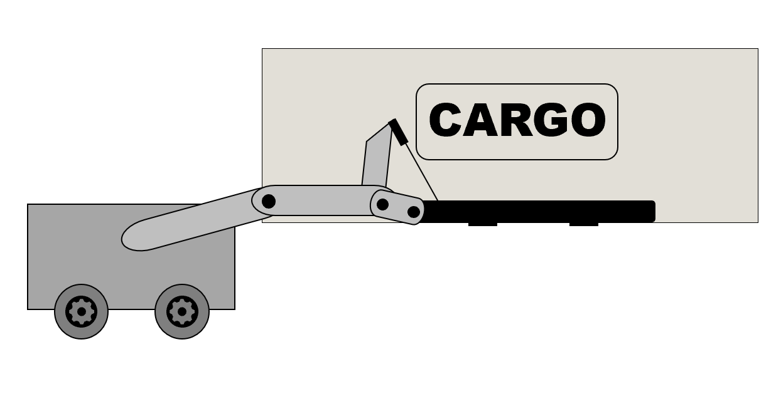
Concept #51 | Honeycomb cargo enclosure – The honeycomb provides more area without using more material and this would be useful in a modular system having multiple honeycomb compartments on the vehicle. A mechanical arm can also be added to the front of the design to meet the teams lift criteria  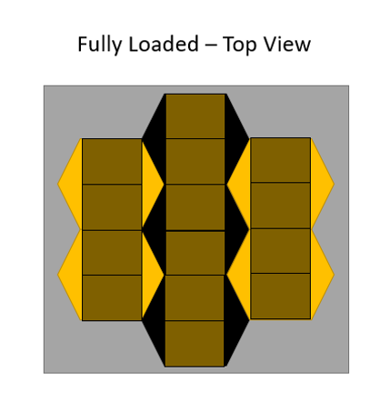  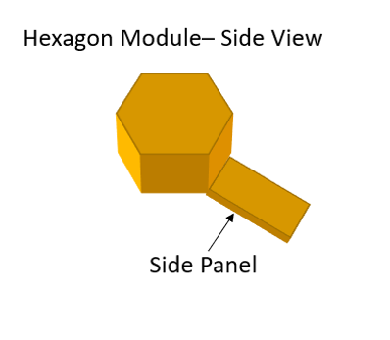  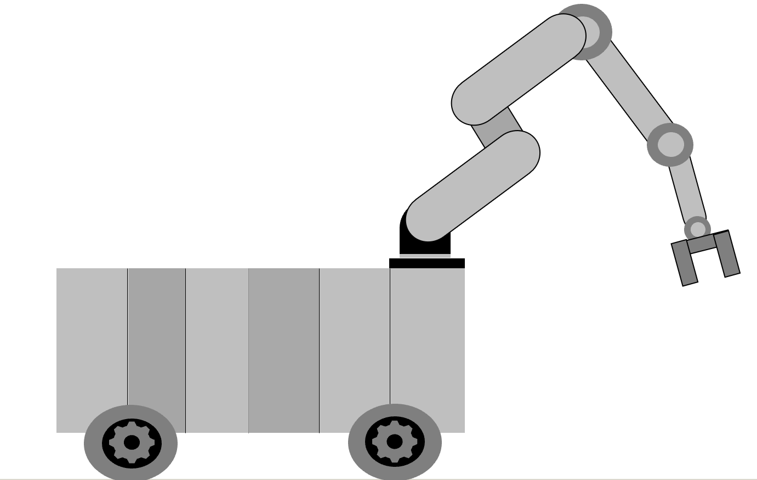
Concept #71 | Snake fangs – a forklift like system with a double fang clamping system, good for clamping boxes and transportation of singular items at a time.  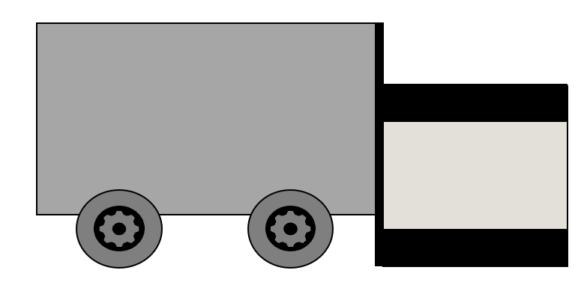
Concept #80 | Modular carrying system – a simple pickup truck like design with a modular cargo bay which can have different shaped or purposed bed designs to accommodate boxes, cylinders, people or loose particle cargo (dirt or rocks). A winch would handle loading needs.  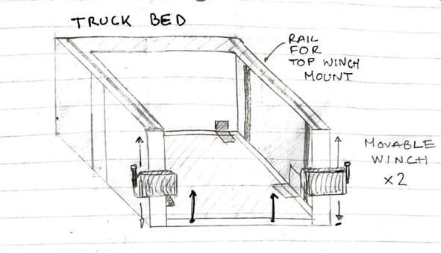
Concept #32 | Expandable bipedal forklift with 2 wheels on each side. This would mimic a car lift device.
High Fidelity Concepts
Concept #37 | This design would mimic Podzilla but instead the legs would be rigid and the side attachment will move up and down such as a fork lift. Each post will have a double wheel design.  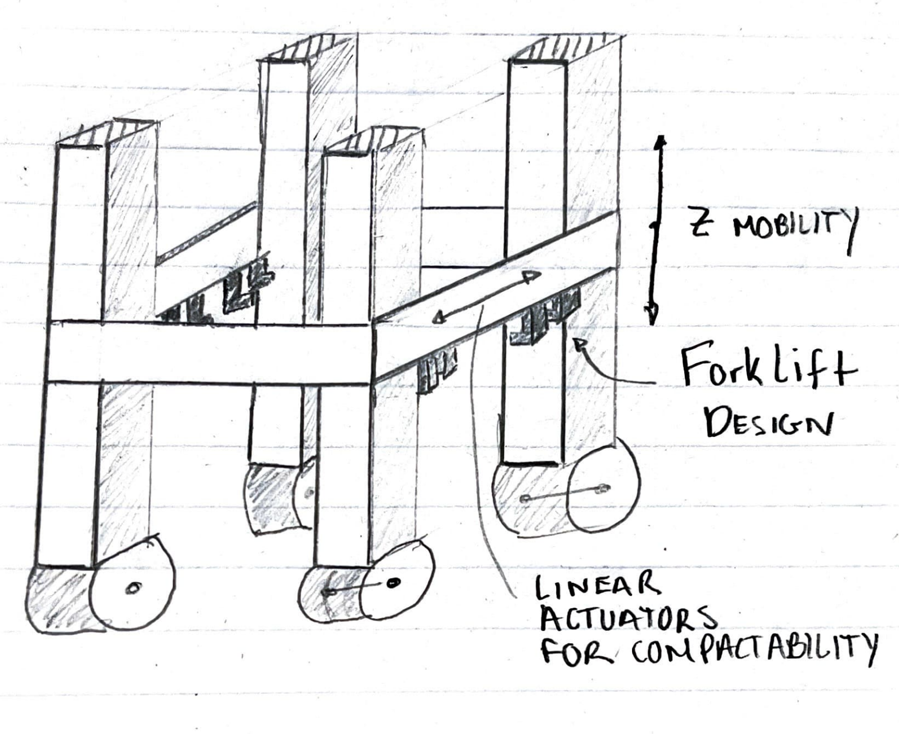
Concept #66 | Flower-like arching legs. It would settle over cargo and a top system would lift the cargo up and back down to the ground  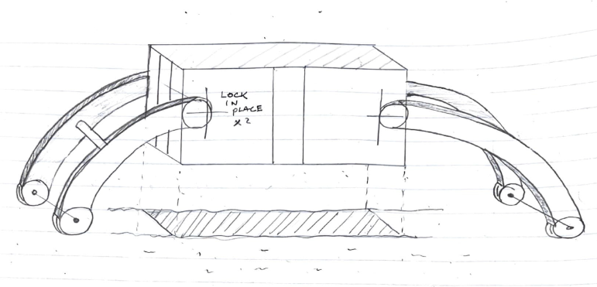
Concept #100 | This design would have a seesaw tilt bed design. It would have a hook that would latch onto the cargo and a pulley system would drag it back the incline. It would level out and then tilt the opposite way to drop the cargo off.  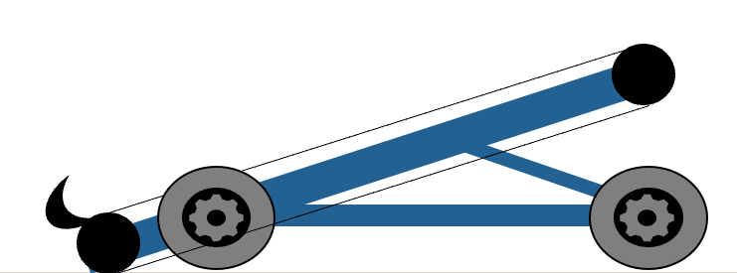  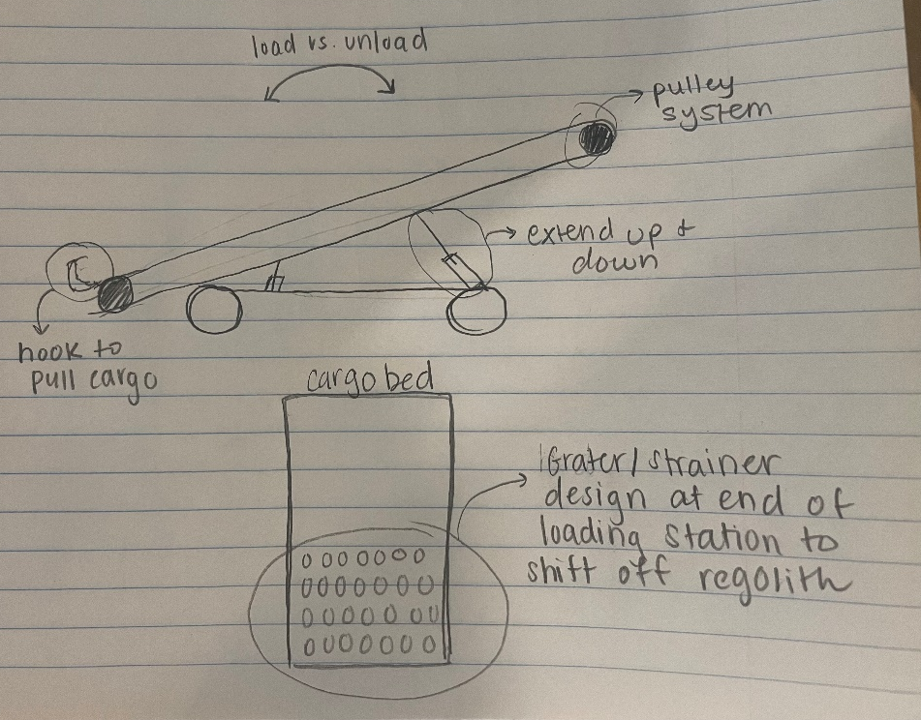

1.6 Concept Selection
Binary Pairwise Comparison
During concept generation, one hundred ideas were gathered and recorded in Appendix D. To properly evaluate these ideas to select a final design, the customer requirements and engineering characteristics of the design were first decided. To condense our table sizes, each of these was assigned a number which can be identified in Table 4.
Table 4: Legend for Customer Requirements and Engineering Characteristics
Number | Customer Requirements | Engineering Characteristics
1 | Power storage system | Fit within rocket
2 | Lift assist mechanism | Collapsible volumetric footprint
3 | Adaptable to multiple payloads | Supports 1.4*max working load
4 | Supports 1 metric ton | Secures cargo (prevents shift)
5 | Capable of reaching 6 km/h | Device stability when lifting/loading
6 | Autonomous pathing | Complete 8 hour working cycle
7 | -- | Power source capable of powering all subsystems
8 | -- | Convert power to movement
9 | -- | Lift maximum weight
10 | -- | Ground clearance
11 | -- | Device stability transporting over rough terrain
12 | -- | Device location feedback
13 | -- | Stays within allowable deviation during line following
14 | -- | Move cargo at certain speed

A binary pairwise comparison matrix was created by inputting the customer needs into the rows and columns of Table 5. These needs were then evaluated against one another outputting either a binary ‘1’ or ‘0’. This matrix tool outputs the important weight factor for each customer requirement. The weight factor is then utilized in the House of Quality. From the table below, it was determined that the lift assist mechanism and system adaptability requirements were most essential to the design.
Table 6: Binary Comparison Matrix
Customer Needs | 1 | 2 | 3 | 4 | 5 | 6 | 7 | 8 | 9 | 10 | Total
1- Power storage system | - | 1 | 1 | 0 | 0 | 0 | 0 | 1 | 0 | 0 | 3
2 - Lift assist mechanism | 0 | - | 1 | 0 | 0 | 0 | 0 | 0 | 0 | 0 | 1
3 - Adaptable to multiple payloads | 0 | 0 | - | 0 | 0 | 1 | 0 | 0 | 0 | 0 | 1
4 - supports 1 metric ton | 1 | 1 | 1 | - | 0 | 1 | 0 | 0 | 1 | 1 | 6
5 - capable of reaching 6 km/h | 1 | 1 | 1 | 1 | - | 1 | 1 | 0 | 1 | 1 | 8
6 - Autonomous pathing | 1 | 1 | 0 | 0 | 0 | - | 0 | 1 | 0 | 0 | 3
7 - Budget of $2000 | 1 | 1 | 1 | 1 | 0 | 1 | - | 1 | 1 | 1 | 8
8 - Weighs less than 1.4 metric tons | 0 | 1 | 1 | 1 | 1 | 0 | 0 | - | 0 | 0 | 4
9 - Designed within rocket constraints | 1 | 1 | 1 | 0 | 0 | 1 | 0 | 1 | - | 0 | 5
10 - Scaled hardware-based prototype | 1 | 1 | 1 | 0 | 0 | 1 | 0 | 1 | 1 | - | 6
Total | 6 | 8 | 8 | 3 | 1 | 6 | 1 | 5 | 4 | 3
Check: (n-1) | 9 | 9 | 9 | 9 | 9 | 9 | 9 | 9 | 9 | 9

The House of Quality includes the list of customer requirements as rows and the list of engineering characteristics as columns. The goal of this matrix is to determine which engineering characteristics are critical to satisfy within the design according to the customer requirements. Moving from row to column, the team determined if the characteristic would contribute to fulfilling the customer's need and subsequently gave a ranking of 0, 1, 3, and 9 to make the final rankings distinct. Nine demonstrates a very significant need. Each end raw score was multiplied by a weight factor, a higher end score correlated to a higher ranking of the categories chosen. The engineering characteristics that ranked within the top three were: design fits within rocket constraints, has ground clearance supports the maximum weight, and converts power to movement.
Table 7: House of Quality
 |  | Engineering Characteristics
Improvement  Direction |  | ↓ | ↑ | = | ↑ | ↑ | = | ↑ | ↑ | = | ↑ | ↑ | = | ↓ | ↓
Units |  | m^3 | lbf | degrees | km/h | degrees | W | kWh | Newtons | lbf | meters | degrees | meters | degrees | degrees
Customer  Requirements | Importance  Weight Factor | 1 -Fit within Rocket | 2 - Collapsible volumetric footprint | 3 - Supports 1.4*Max Working load | 4 - Secure Cargo (Prevent shift) | 5 -Device stability when lifting/loading | 6 - Complete 8 hour working cycle | 7 - Power source capable of powering all subsystems | 8 - Convert power to movement | 9 - Lift maximum weight | 10 - Ground Clearance | 11 - Device stability transporting over rough terrain | 12 - Device location feedback | 13 - Stays within allowable deviation during line following | 14 - Move cargo at desired speed
1- Power storage system | 3 | 3 | 7 | 5 | 5 | 3 | 9 | 1 | 9 | 5 | 3 | 5 | 5 | 7 | 3
2 - Lift assist mechanism | 1 | 1 | 1 | 5 | 5 | 1 | 5 | 1 | 5 | 5 | 5 | 5 | 5 | 7 | 3
3 - Adaptable to multiple payloads | 1 | 3 | 1 | 5 | 5 | 1 | 3 | 3 | 3 | 5 | 3 | 3 | 7 | 7 | 5
4 - supports 1 metric ton | 6 | 7 | 9 | 1 | 1 | 5 | 1 | 3 | 5 | 7 | 5 | 3 | 5 | 5 | 1
5 - capable of reaching 6 km/h | 8 | 5 | 5 | 1 | 3 | 3 | 5 | 3 | 3 | 3 | 7 | 3 | 7 | 3 | 5
6 - Autonomous pathing | 3 | 1 | 3 | 3 | 3 | 1 | 3 | 1 | 1 | 3 | 7 | 1 | 9 | 5 | 3
7 - Budget of $2000 | 8 | 9 | 9 | 5 | 9 | 5 | 5 | 5 | 7 | 7 | 7 | 7 | 5 | 7 | 1
8 - Weighs less than 1.4 metric tons | 4 | 5 | 5 | 9 | 7 | 7 | 9 | 5 | 7 | 7 | 7 | 5 | 7 | 7 | 3
9 - Designed within rocket constraints | 4 | 5 | 5 | 7 | 7 | 9 | 7 | 5 | 7 | 7 | 5 | 5 | 3 | 7 | 3
10 - Scaled hardware-based prototype | 6 | 1 | 5 | 5 | 3 | 3 | 3 | 1 | 5 | 3 | 7 | 3 | 7 | 5 | 3
Raw Score | 3040 | 216 | 268 | 182 | 210 | 190 | 204 | 156 | 268 | 270 | 220 | 224 | 158 | 330 | 144
Relative Weight % | 100.0 | 7.1 | 8.8 | 6.0 | 6.9 | 6.3 | 6.7 | 5.1 | 8.8 | 8.9 | 7.2 | 7.4 | 5.2 | 10.9 | 4.7
Rank Order | - | 7 | 3 | 11 | 8 | 10 | 9 | 13 | 3 | 2 | 6 | 5 | 12 | 1 | 14

From the House of Quality, the team was able to determine the top three engineering characteristics which need to be stressed in the final design process.
Pugh Chart
The Pugh Chart is a relative comparison technique. It creates down selected concepts by relatively comparing the engineering characteristics to a datum concept. Here, it is decided if the concept is better (+), worse (-), or the same in comparison (S). The number of better, worse, and satisfactory were counted and used to eliminate and rank ideas. The chosen datum was a concept tokened “Podzilla” by the moving company “PODS.” This design moves over the storage container and then forms to the space requirements and subsequently lifts the device. Since this design was used a base model for many of the team’s design concepts, it was also used as the benchmark.

Table 8: First Pugh Chart Iteration
Function | Datum | Concepts
 |  | Atlas | Bipedal Forklift | Honeycomb Cargo Bay | Snake Fang Lift | Modular pickup truck | Seesaw | Quadzilla | Sunflower
1 -Fit within Rocket | Pods - Podzilla | - | - | + | - | S | + | + | +
2 - Collapsible volumetric footprint |  | - | - | + | - | - | - | + | -
3 - Supports 1.4*Max Working load |  | + | + | - | + | + | + | + | S
4 - Secure Cargo (Prevent shift) |  | + | + | + | - | - | + | - | -
5 -Device stability when lifting/loading |  | + | - | - | + | + | - | - | +
6 - Complete 8 hour working cycle |  | + | + | - | + | + | S | + | +
7 - Power source capable of powering all subsystems |  | - | S | + | S | S | + | - | S
8 - Convert power to movement |  | S | - | - | + | - | + | + | +
9 - Lift maximum weight |  | + | + | - | - | S | S | + | +
10 - Ground Clearance |  | - | S | S | - | S | - | + | +
11 - Device stability transporting over rough terrrain |  | S | - | S | + | S | + | - | S
12 - Device location feedback |  | - | - | S | - | - | + | + | +
13 - Stays within allowable deviation during line following |  | S | S | - | S | S | + | + | +
14 - Move cargo at desired speed |  | + | - | S | S | S | + | S | +
Number of pluses (+) |  | 6 | 4 | 4 | 5 | 3 | 9 | 9 | 9
Number of Satisfactory (S) |  | 3 | 3 | 4 | 3 | 7 | 2 | 1 | 3
Number of minuses (-) |  | 5 | 7 | 6 | 6 | 4 | 3 | 4 | 2

After the first iteration of the Pugh Chart, the three highest scoring designs were evaluated in a second Pugh Chart. These designs included: Seesaw, Sunflower, and Quadzilla. The new datum was the snake fang system.
Table 9: Second Pugh Chart Iteration
Table 9: Pugh Chart Second Iteration
Function | Datum | Concepts
 |  | Sunflower | Quadzilla | Seesaw system | Atlas
1 -Fit within Rocket | Snake Fang Lift | + | + | + | S
2 - Collapsible volumetric footprint |  | S | + | - | -
3 - Supports 1.4*Max Working load |  | - | + | + | +
4 - Secure Cargo (Prevent shift) |  | + | - | S | +
5 -Device stability when lifting/loading |  | S | - | - | -
6 - Complete 8 hour working cycle |  | + | S | + | S
7 - Power source capable of powering all subsystems |  | S | + | S | -
8 - Convert power to movement |  | - | S | - | +
9 - Lift maximum weight |  | S | - | + | -
10 - Ground Clearance |  | + | + | S | -
11 - Device stability transporting over rough terrain |  | S | - | + | -
12 - Device location feedback |  | + | + | - | S
13 - Stays within allowable deviation during line following |  | S | + | + | +
14 - Move cargo at desired speed |  | S | S | - | S
Number of pluses (+) |  | 5 | 7 | 6 | 4
Number of Satisfactory (S) |  | 7 | 3 | 3 | 4
Number of minuses (-) |  | 2 | 4 | 5 | 6

After the second iteration of the Pugh Chart, Quadzilla was found to be the best concept with seven pluses in comparison to six pluses for the seesaw and five for the sunflower designs.
Analytical Hierarchy Process
The Analytical Hierarchy Process (AHP) is used to determine which engineering characteristics are most significant. The process involves evaluating each engineering characteristic against the other to see which is more important to the project goals. AHP validates the concept selection within the Pugh Chart and ensures the criteria weights were not biased to a particular design. An AHP table was created for each of the fourteen determined engineering characteristics. These tables can be found in Appendix E. Table 10 displays the final ratings chart for the Analytical Hierarchy Process which gives the relative weight of each selection criteria.
Table 10: Analytical Hierarchy Process (Normalized)
Normalized Criteria Comparison Matrix [NormC]
 | 1 | 2 | 3 | 4 | 5 | 6 | 7 | 8 | 9 | 10 | 11 | 12 | 13 | 14 | Criteria Weights {W}
1 -Fit within Rocket | 0.325 | 0.609 | 0.426 | 0.193 | 0.302 | 0.215 | 0.206 | 0.186 | 0.308 | 0.181 | 0.131 | 0.122 | 0.090 | 0.133 | 0.245
2 - Collapsible volumetric footprint | 0.046 | 0.087 | 0.256 | 0.116 | 0.130 | 0.072 | 0.124 | 0.062 | 0.185 | 0.060 | 0.131 | 0.095 | 0.127 | 0.057 | 0.110
3 - Supports 1.4*Max Working load | 0.065 | 0.029 | 0.085 | 0.193 | 0.216 | 0.119 | 0.124 | 0.062 | 0.308 | 0.060 | 0.078 | 0.068 | 0.090 | 0.095 | 0.114
4 - Secure Cargo (Prevent shift) | 0.065 | 0.029 | 0.017 | 0.039 | 0.009 | 0.119 | 0.206 | 0.104 | 0.012 | 0.060 | 0.131 | 0.068 | 0.054 | 0.095 | 0.072
5 -Device stability when lifting/loading | 0.046 | 0.029 | 0.017 | 0.193 | 0.043 | 0.119 | 0.124 | 0.145 | 0.012 | 0.101 | 0.078 | 0.068 | 0.090 | 0.057 | 0.080
6 - Complete 8 hour working cycle | 0.036 | 0.029 | 0.017 | 0.008 | 0.009 | 0.024 | 0.008 | 0.145 | 0.012 | 0.141 | 0.009 | 0.068 | 0.090 | 0.095 | 0.049
7 - Power source capable of powering all subsystems | 0.065 | 0.029 | 0.028 | 0.008 | 0.014 | 0.119 | 0.041 | 0.145 | 0.021 | 0.101 | 0.183 | 0.095 | 0.090 | 0.095 | 0.074
8 - Convert power to movement | 0.036 | 0.029 | 0.028 | 0.008 | 0.006 | 0.003 | 0.006 | 0.021 | 0.012 | 0.060 | 0.078 | 0.068 | 0.090 | 0.095 | 0.039
9 - Lift maximum weight | 0.065 | 0.029 | 0.017 | 0.193 | 0.216 | 0.119 | 0.124 | 0.104 | 0.062 | 0.101 | 0.131 | 0.095 | 0.054 | 0.095 | 0.100
10 - Ground Clearance | 0.036 | 0.029 | 0.028 | 0.013 | 0.009 | 0.003 | 0.008 | 0.007 | 0.012 | 0.020 | 0.005 | 0.068 | 0.090 | 0.057 | 0.028
11 - Device stability transporting over rough terrain | 0.065 | 0.017 | 0.028 | 0.008 | 0.014 | 0.072 | 0.006 | 0.007 | 0.012 | 0.101 | 0.026 | 0.068 | 0.054 | 0.095 | 0.041
12 - Device location feedback | 0.036 | 0.012 | 0.017 | 0.008 | 0.009 | 0.005 | 0.006 | 0.004 | 0.009 | 0.004 | 0.005 | 0.014 | 0.006 | 0.004 | 0.010
13 - Stays within allowable deviation during line following | 0.065 | 0.012 | 0.017 | 0.013 | 0.009 | 0.005 | 0.008 | 0.004 | 0.021 | 0.004 | 0.009 | 0.041 | 0.018 | 0.006 | 0.017
14 - Move cargo at desired speed | 0.046 | 0.029 | 0.017 | 0.008 | 0.014 | 0.005 | 0.008 | 0.004 | 0.012 | 0.007 | 0.005 | 0.068 | 0.054 | 0.019 | 0.021
Sum | 1.000 | 1.000 | 1.000 | 1.000 | 1.000 | 1.000 | 1.000 | 1.000 | 1.000 | 1.000 | 1.000 | 1.000 | 1.000 | 1.000 | 1.000

From this chart the relative weights were used to calculate the alternative value through matrix multiplication with the final rating matrix transposed to determine which idea was selected.
Final Selection
After narrowing down which characteristics were deemed most important using the Analytical Hierarchy process, we compared each of the top three against each individual selection criteria. The results from this can be seen in Table 11.
Table 11: Final Values for each Design Selection
Concept | Alternative Value
Quadzilla | 0.503
Sunflower | 0.242
Seesaw System | 0.255

The results demonstrated that the design termed “Quadzilla” best met the selection criteria which matches the results found from the Pugh Chart. This would include four rigid structures bounded by a moveable attachment. This attachment would raise to the top to allow the rover to settle over the desired cargo. Then it would move down to a desired location to lift the cargo off the ground using a forklift design at four locations. This device should be stable and steady enough to transport the loads between locations. Additionally, linear actuators located on each side of the moveable attachment would allow the device to compact onto itself to account for the rocket size and volumetric constraints. Even with a double wheel design at each pole, the design should be relatively low weight in comparison to the load it will be expected to lift.
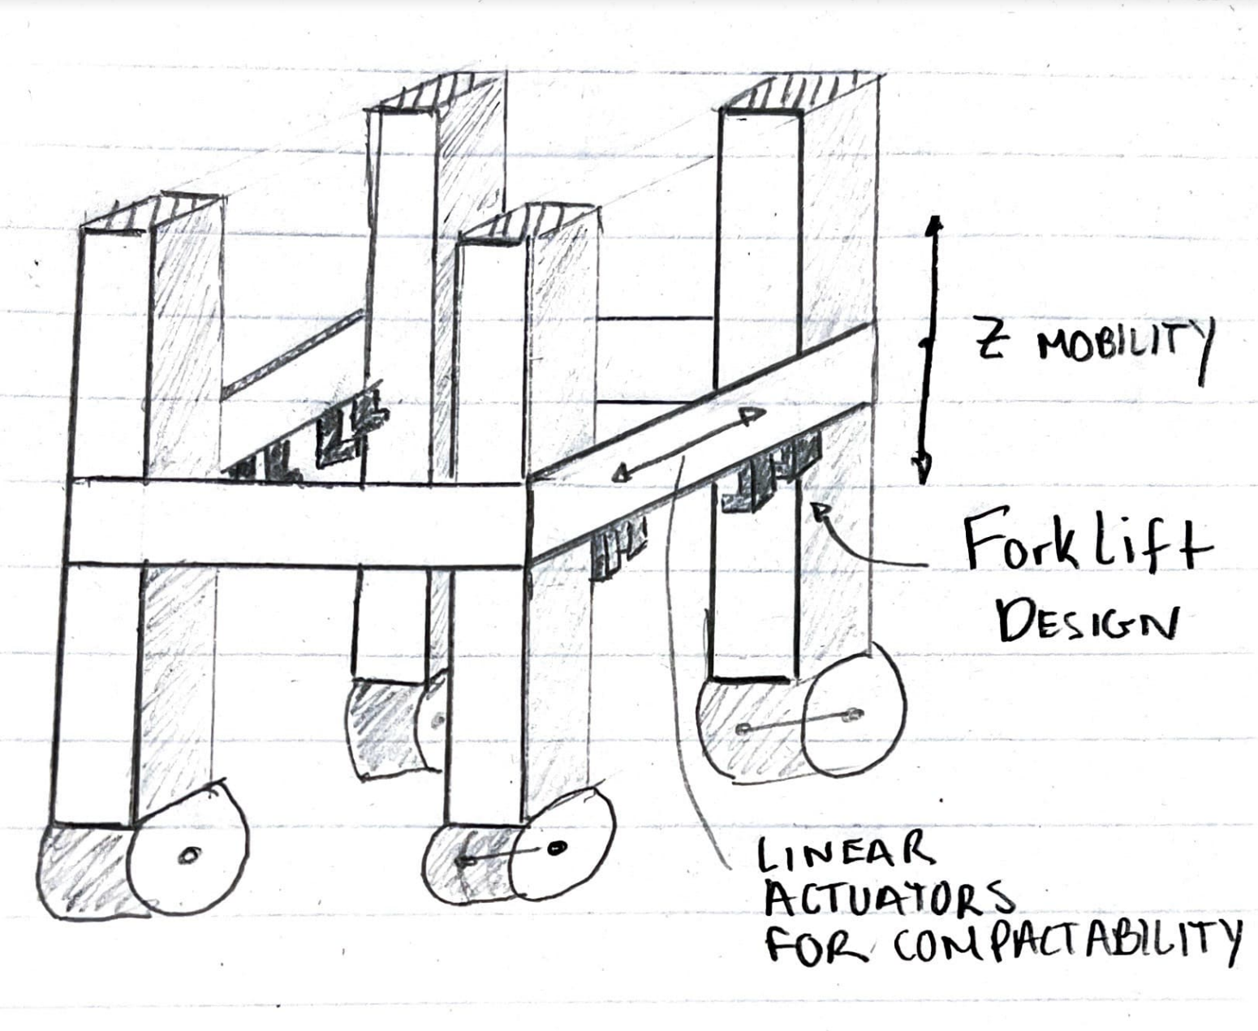
Figure 2: Rough Sketch of Initial Design

1.8 Spring Project Plan

Chapter Two: EML 4552C

2.1 Spring Plan

Project Plan.

Build Plan.

Appendices

Appendix A: Code of Conduct
This document will serve as the team contract for Team 517 during the entire Senior Design period lasting from the Fall of 2022 through the Spring of 2023.
Mission Statement
To work collaboratively as a team to produce the best solution for the lift and transportation of large loads on the lunar surface, while considering the needs and requirements described by our customer. The team intends to employ the engineering design principles, knowledge, and experience learned throughout our undergraduate careers while behaving in a professional manner.
Outside Obligations
The Senior Design team should meet twice weekly at a minimum, during the remaining lecture time every Tuesday and Thursday, these will be the general team meetings. Additional meetings can be scheduled accordingly based on the availability of members and necessity. For outside obligations, during additional meetings, the Microsoft Teams calendar is used to communicate availability and other commitments. Meetings with the team’s faculty advisor and team sponsor should occur bi-weekly. All team members should be present at the general meetings except for situations which are effectively communicated prior to the meeting time.
Team Roles
The following team roles have been agreed upon for the course of the project. Team roles should be reevaluated at the beginning of the spring semester or as deemed necessary.

Team Member | Team Role
Cameron Barnes | Systems Engineer, Mechatronics Engineer, Point of Contact
Cole Gutknecht | Materials Engineer
Tyler Ince-Ingram | Test Engineer
Rafael Meza | Dynamic Systems Engineer
Michael Wyrick | Design Engineer
As the team learns more about the project details, additional roles may be assigned, or role changes can be made with unanimous agreement of the team.
Communication
The team should put the necessary files, scheduling, and communication primarily in the Teams site. The IMessage group chat should only be used to communicate informally. Official communication with Sponsors, Dr. McConomy, and other mentors should primarily be communicated through email and should have all the group members copied. If no response is received in 24 hours for team members and 72 hours for non-team members a follow-up email must be sent by the original sender of the email.
When responding in a professional setting be polite and understanding. Meeting notes will be taken in every meeting, and everyone will upload their notes to one document on Teams. If a team member misses a meeting for whatever reason, it is their responsibility to look at the recorded notes from the other team members and stay up to date with all project details.
Dress Code
General team meetings are considered informal events and a specific dress code is not specified. For Sponsor meetings, Virtual Design Reviews, or advising meetings, either in person or online, the team is expected to dress in business casual attire. Business Casual refers to dress pants, dress shoes, and button down for men; Dresses, dress pants, blouses, and dress shoes are acceptable for women; blazer and tie are optional. On Senior Design Day the team should dress as Business Professional. Team members at the baseline should be presentable during any project event.
Attendance Policy
The attendance policy for the team is as follows. Attendance for normal class falls under personal responsibility. Team members are responsible for attending general meetings Tuesday’s and Thursday’s during the excess allotted lecture time. If a member must miss either an in-class or outside group meeting, they should notify the rest of the team in the IMessage group chat. Additionally, if a member misses 3 scheduled team meetings throughout the semester, even with prior notice, they must provide their team with a written response regarding how future meetings can be better scheduled to suit their schedule. Team members are expected to provide an emailed notice of concern to the absent member. However, if an individual misses more than 3 team meetings without prior notice, external support will be sought through Dr. McConomy. Use of a vacation day for team assignments must be agreed by all team members. The decision to use the vacation day must be made at least 48 hours prior to the due date.

Contacting Dr. McConomy
Contact with McConomy/ TAs should be made through email and all team members must be copied to ensure they are notified. Contact should only be made, when necessary, situations that may apply:
  - Sponsor is currently unavailable or has given no response for an extended period inhibiting the progress of the group.
  - Problems among group members that the group has been unable to resolve even after discussion.
Purchasing
Purchase orders for this project shall be handled by the entire team with guidance from Dr. Oates on larger purchases. Team members are expected to voice their opinion to reach consensus before spending money from the budget. By submitting an order all members have agreed and are responsible for the product. Cameron Barnes will be responsible for communicating with Pro Hruda for purchasing orders. In case the project exceeds the current limit of the budget, the team agrees to track total personal spending for the project and split the incurred costs between all five group members.

Amendments
This document can be amended at any point during the project duration with unanimous agreement of the team. The amendment must be clearly communicated and understood by all members. There is no need to resign the document if a change is made.

Statement of Understanding
By signing you agree to the entire document and will uphold all that is said above.

Signatures:
________________________
___________________________

___________________________
Date:

1/12/2023

1/12/2023

1/12/2023

1/12/23
___________________________

1/12/2023

___________________________

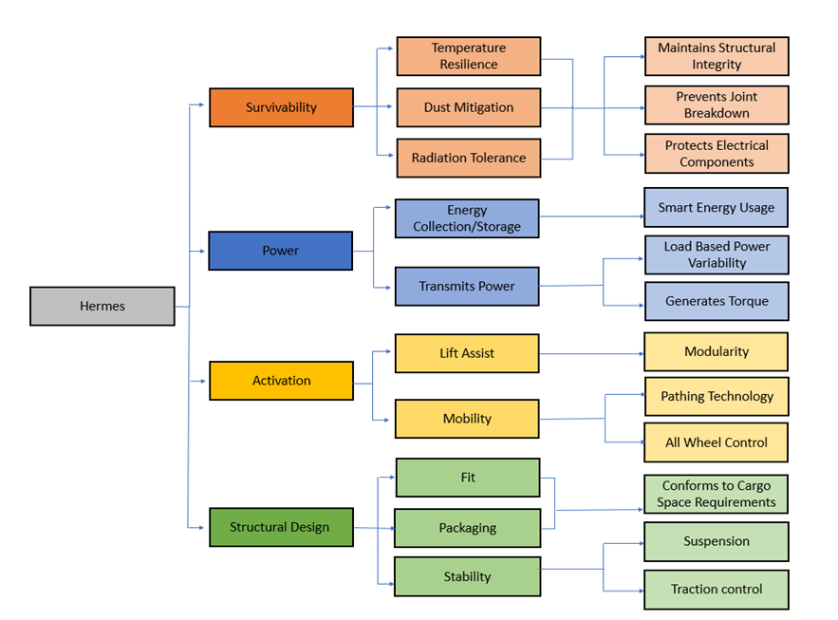
Appendix B: Functional Decomposition
Figure 2: Functional Decomposition Hierarchy Chart

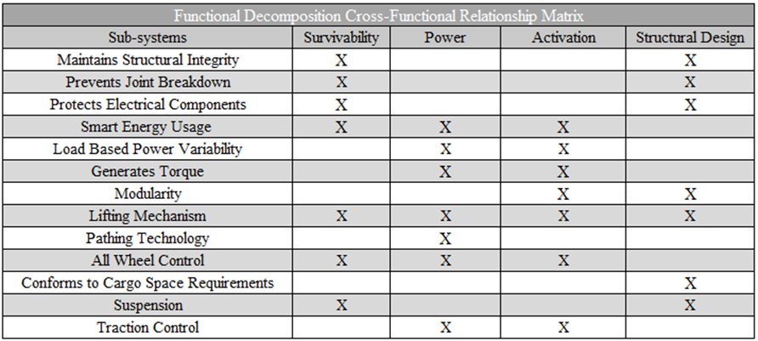
Table 1: Cross-Functional Relationship Matrix

Appendix C: Target Catalog
Table 2: Targets and Metrics Breakdown
System | Function | Target (Real) | Target (Prototype) | Metric
Structural Design | Fit within the confines of the rocket cargo space. | The SpaceX Starship cargo area is approximately 9 meters in diameter and 50 meters tall. The vehicle should fit within approximately 85% of the total diameter. No more than 5 meters in height. | The SpaceX Starship cargo area is approximately 9 meters in diameter and 50 meters tall. The vehicle should fit within approximately 85% of the total diameter. No more than 5 meters in height. | Measure the device dimensions with a meter stick once it is fully compact
Structural Design | The vehicle should be rated for 1400kg. | The vehicle should be rated for 93 kg. | Load analysis | The vehicle should be rated for 1400kg.
Structural Design | The vehicle should not roll over during loading, transport, or against adverse disturbances. | The roll angle of the vehicle should not exceed 10 degrees under regular usage circumstances | The roll angle of the vehicle should not exceed 10 degrees under regular usage circumstances | The clearance angle measured between the lowest front/ rear point and the wheel
Power | Provide a variable amount of power based on the load being carried. | The device should move at a constant speed of 5 km/hr | The device should move at a constant speed of 5 km/hr | This will be measured through the use of a speedometer
Activation | Device remains stable when lifting | The bottom platform should stay parallel (180 degrees) to the surface during lift. | The bottom platform should stay parallel (180 degrees) to the surface during lift. | Level measurement instrument
Mobility | Traverse uneven/rough surfaces | The bottom platform should stay parallel (180 degrees) to the surface during transport | The bottom platform should stay parallel (180 degrees) to the surface during transport | Level measurement instrument

Appendix D: 100 Concepts
- CS- Scaffold frame with Sweeping hook and collapsible bottom plate on separate moving axis's
- Scaffold frame with traversable up and down motion crate style grab
- 6 wheeled Body centered forklift with regular forks
- 4 wheeled Body centered forklift with regular forks
- 3 wheeled Body centered forklift with regular forks
- 6 wheeled Body centered forklift with flat plate
- 4 wheeled Body centered forklift with flat plate
- 3 wheeled Body centered forklift with flat plate
- Scaffold frame xyz lift picks up by closing the body and using tension/grip strength to hold and lift traversing up flat angled grip impact points
- Scaffold frame xyz lift picks up by closing the body and using tension/grip strength to hold and lift traversing up semicircular grip impact points
- Scaffold frame xyz lift picks up by closing the body and using tension/grip strength to hold and lift traversing up squared corner grip impact points
- Centaur-like walking mech
- 6-wheel Flat bed with winch let down ramp winch pulls cargo up ramp onto bed
- 4-wheel Flat bed with winch let down ramp winch pulls cargo up ramp onto bed
- 6-wheel Flat bed with winch retractable/expandable ramp winch pulls cargo up ramp onto bed
- 4-wheel Flat bed with winch retractable/expandable ramp winch pulls cargo up ramp onto bed
- Tank track Flat bed with winch retractable/expandable ramp winch pulls cargo up ramp onto bed
- Tank track Flat bed with winch retractable/expandable ramp winch pulls cargo up ramp onto bed
- 6-wheel Flatbed that has a rear Tilt Bed that would then connect to cargo and tilt back down
- 6-wheel Flatbed that has a side Tilt Bed that would then connect to cargo and tilt back down
- 4-wheel Flatbed that has a rear Tilt Bed that would then connect to cargo and tilt back down
- 4-wheel Flatbed that has a side Tilt Bed that would then connect to cargo and tilt back down
- Tank track Flatbed that has a rear Tilt Bed that would then connect to cargo and tilt back down
- Tank track Flatbed that has a side Tilt Bed that would then connect to cargo and tilt back down
- Scaffolding style – lower bed uplift, pickup truck bed that lifts up and down
- Scaffolding style – Upper bed suspension lift, suspension carriage
- Scaffolding style – podzilla
- Flat bed with spring suspension and crane lift
- Flat bed with spring suspension and forklift
- Crane on front + tug cargo bay area (tow truck type design)
- Hydraulic Pedal lift Rover
- Expandable forklift and hook device
- Moveable hook + bin transport
- MIBOX lift system on back of rover
- CS- MIBOX lift system + cargo bay + crane in front
- Vehicle with a compactable boom on top
- This design would mimic Podzilla but instead would have forklift attachments at the legs and hooks that expand up and down at the top to secure cargo
- Podzilla type design but with a hook on each corner, ship lift device
- Mobile robotic arm with suction cup
- CS- Mobile robotic arm with suction cup + cargo bay area
- Mobile crane + Vacuum lifting device
- Self-propelled modular transporter
- Vertical cask transporter
- AP- mobile vehicle with snowplow attachment on front
- Tank wheel design with compactable crane on top
- Mobile tripod design with hook
- Vehicle with cargo bay and boom pole attached to back
- Bipedal design with grip on each side and a hook on top to secure cargo
- BM - Elephant Trunk Lift Mechanism – A flexible and robust mechanism that is able to rotate and move in multiple orientations, which would be useful in tighter situations.
- BM - Honeybee Hive – A swarm system that focuses on having smaller modules within the storage system to transport cargo back and forth without having to move the whole vehicle. That way more efficient trips can occur during a mission.
- BM – Honeycomb cargo enclosure – The honeycomb provides more area without using more material and this would be useful in a modular system having multiple honeycomb compartments on the vehicle. A mechanical arm can also be added to the front of the design to meet the teams lift criteria
- BM – Clark’s Nutcracker Expandable Pouch – This bird is able to store 150 seeds in its expandable pouch and this would be useful for meeting space requirements while also being able to carry multiple cargo items.
- BM – Grapple Plant Hook – Useful if we want to implement the hooking mechanism to grab specialized cargo packages with a hook attachment to take more items at once.
- BM – Chameleon Tongue – Due to its high speed and accuracy, the Chameleon Tongue would be a useful feature for grabbing objects over longue distances and storing cargo in our vehicles’ mouth-like structure.
- BM – Hummingbirds Beak Snap Shut – The beak of the hummingbird can snap shut do to store elastic energy and this feature would help prevent loss of cargo as the “snapping” mechanism provides enough force to keep any cargo from escaping.
- BM – Sidewinder Rattlesnake Movement Across Sand – The rattlesnake is able to move across sand without slipping by pushing on the ground with parts of its body and lifting the rest sideways. This feature would be used to navigate through lunar regolith and unstable terrain.
- BM – Reticulate Moray Eel Jaws – The use of a secondary set of jaws aids in securing items and would be useful in a crane-like lift mechanism to gain a better hold on the cargo by using a jaw-like structure to safely transport the items.
- BM – Octopus Lift Mechanism – Using the 8 tentacles on an octopus and the suckers would help in attaching on to the cargo and grabbing multiple forms of the cargo to load in the cargo bay of our vehicle.
- FA - The Rolling Hopper – Uses the storage compartment of an oven and a ball shape to roll around on the lunar surface and bounce around with a spring when needed to cover more distance.
- FA – Spring Loaded Cargo – Would use the inside of a ball with an oven door and spring inside to propel the cargo out of the storage and it would roll around the lunar surface to pick up more items.
- FA – Namaste – Ball-like structure slowly navigates through the lunar surface and uses oven knobs to open and close a spring-loaded oven door that quickly snaps shut when needed.
- FA – Buns in the Oven – Ball-like mechanism is shot out of an oven through a spring and opens to grab cargo in its path, then it retracts back into the oven stored on the vehicle.
- FA – Oven Crane – Spring-loaded crane that has a ball with a compartment on the inside that is propelled directly towards the cargo, and it retracts back up and stored inside of the ball.
- Airplane wheel design with 4 double wheels on the vehicle
- Double crane-like structure to grab more than one cargo package
- Sunflower-like blooming legs to grab packages and lift them back up
- Telescoping legs to grab packages and load into cargo bay and then extend to lift them back up.
- BM - Beetle Rolling dirt – cargo area can be a sort of vertically stabilized bearing with weight so that the load doesn’t move but the driving motor can roll the cylindrical or spherical cargo bay.
- BM - Mule like transportation – a robust locomotive that can be manually loaded on three sides to carry multiple types and sizes of cargo, carries the cargo on its “back”.
- BM - The goat train – a robust locomotive made for pure pulling power which can have carts or crate areas attached to the back pulling loads over the lunar surface.
- BM - The Camel back – a vehicle with many compartments, mainly a central cargo area hollowed out in the middle section of the chassis with a front engine compartment and a rear trunk. Cargo is stored in that camel back M shape.
- Magnetic Lift trolley – requires a magnetic circuit to be mobile but can provide an energy free chassis where the power needs to be only fed to the rail system. Can carry as large of a load as the magnetic field allows.
- BM – Pelican Beak – a rear wheel drive vehicle with an expanding frontal cargo bay which contracts to secure items in place. A big clamp with a flexible bottom half.
- BM – Snake fangs – a forklift like system with a double fang clamping system, good for clamping boxes and transportation of singular items at a time.
- FA – Dead lifter – a mechanical lift that begins in a collapsed position and with a rectangular cargo bay “stands up” lifting the load just to provide the clearance for transportation.
- FA – Sled push – Rear wheel drive vehicle which pushes cargo around the lunar surface. Pushing on skis shouldn’t lift excessive regolith, can help create level ground.
- FA – Strong man – A device which can slowly walk on the surface of the moon which carries cargo strapped to its “back”. Velocity is very slow but allows for large range of vertical motion by bending at the knees.
- FA – Cartwheel carry – The entire vehicle is a large cylinder or tire which has a loading area in the center and simply rolls from point A to point B.
- FA – Rock climbing – A large “hand” or clamping mechanism which wraps around and grips cargo to lift so that transportation can occur.
- Modular carrying system – a simple pickup truck like design with a modular cargo bay which can have different shaped or purposed bed designs to accommodate boxes, cylinders, people or loose particle cargo (dirt or rocks). A winch would handle loading needs.
- Battery module lift – dedicated crane system for moving heavy loads, specialized for lift, restricted transportation ability.
- Flatbed transport with spike wheels- Spike wheels are good for breaking potential ice and mitigate regolith kick up.
- 4-wheel flatbed design that could follow a set magnetic path from point A to point B. (magnet could act as suspension).
- 6-wheel flatbed design that could follow a set magnetic path from point A to point B (helps spread weight on vehicle which is good for heavy lift).
- 4-wheel flatbed design that could follow a set railroad from point A to point B. (railroad would be better for stabilization).
- 6-wheel flatbed design that could follow a set railroad from point A to point B (helps spread weight on vehicle which is good for heavy lift).
- 4-wheel design that has cables overhead along the whole path that delivers electricity.
- 6-wheel design that has cables overhead along the whole path that delivers electricity.
- 8 -wheel design that has cables overhead along the whole path that delivers electricity.
- 12 -wheel design that has cables overhead along the whole path that delivers electricity.
- Flat bed with tank tread.
- Sling ring from avengers
- A large slide to carry materials from point A to point B
- Attach a cord to the cargo the length of the distance to the landing point and launch the cargo into lunar orbit
- Big magnet strapped to cargo put on rails and another big magnet at the destination
- The beam from star trek to teleport material from point A to point B
- Catapult and landing pad for robust cargo
- Teleportation
- Tractor beam from Star Wars to
- This design would have a seesaw tilt bed design. It would have a hook that would latch onto the cargo and a pulley system would drag it back the incline. It would level out and then tilt the opposite way to drop the cargo off.

Appendix E Concept Selection Tables

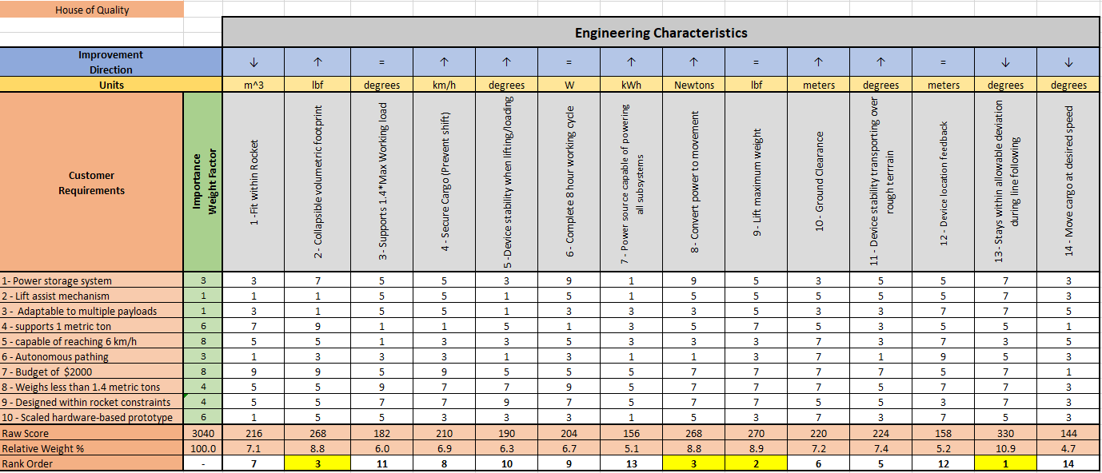
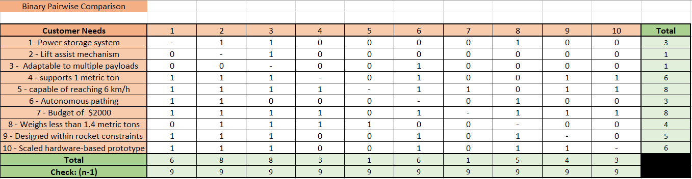
Table 4 House of Quality (HoQ)

Table 3 Binary Pairwise Comparison
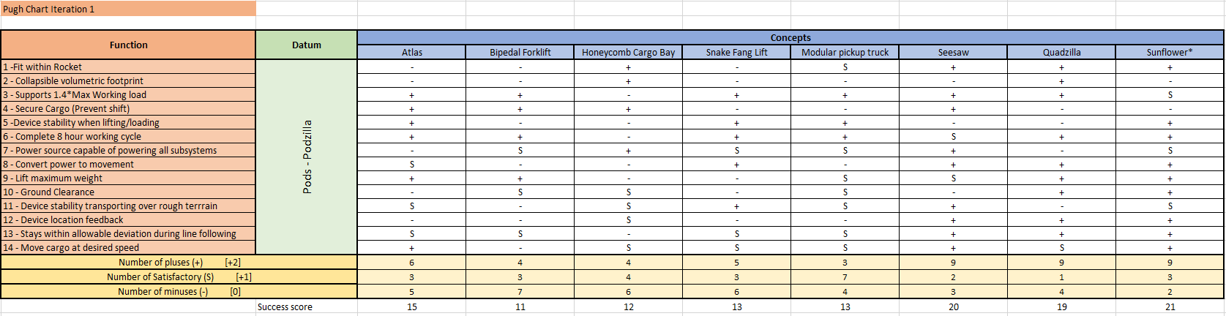
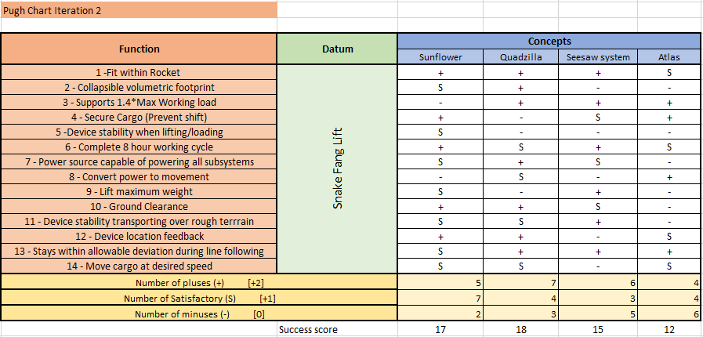
Table 6 Pugh Chart (Iteration 2)
Table 5 Pugh Chart (Iteration 1)
Table 6 Pugh Chart (Iteration 2)

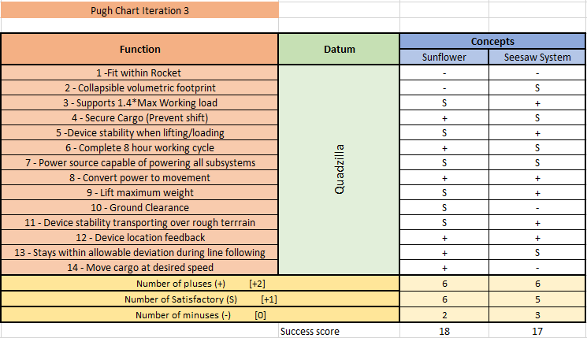
Table 7 Pugh Chart (Iteration 3)

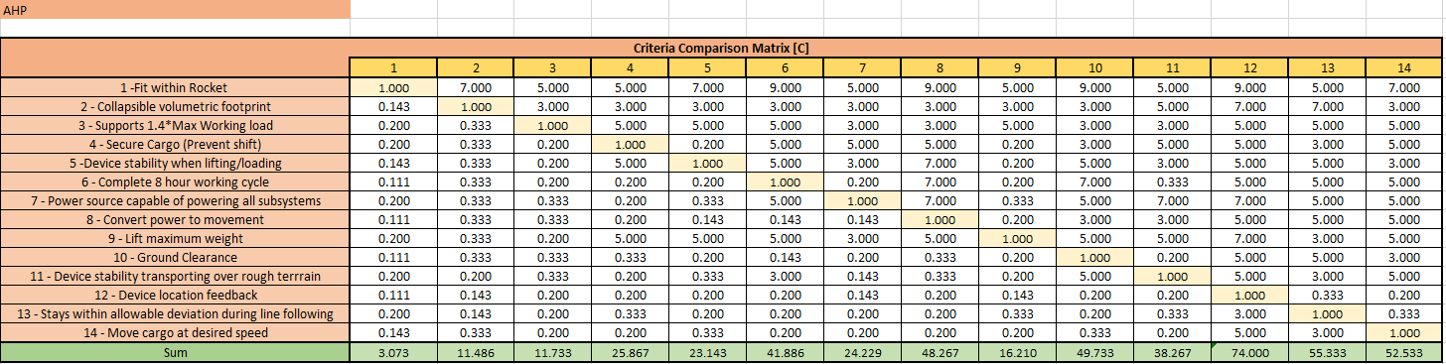
Table 8 Analytical Hierarchy Process Criteria Comparison
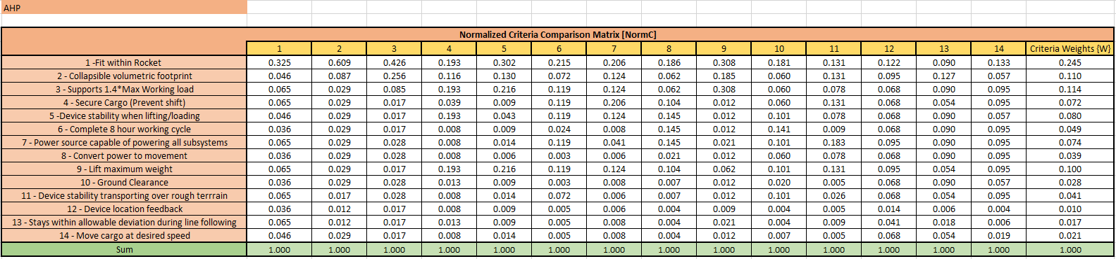
Table 9 Normalized Criteria Comparison Matrix for AHP

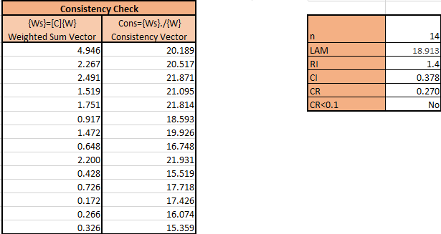
Table 10 Consistency Check

Table 11 Criteria Comparison Matrix for Fit in Rocket
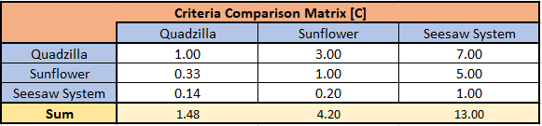

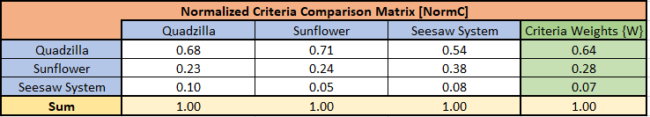
Table 12 Normalized Criteria Comparison Matrix for Fit in Rocket

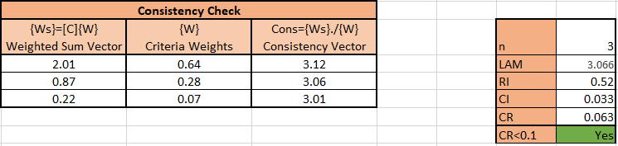
Table 13 Consistency Check for Fit in Rocket

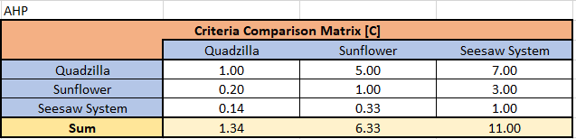
Table 14 Criteria Comparison Matrix for Collapsible Volumetric Footprint
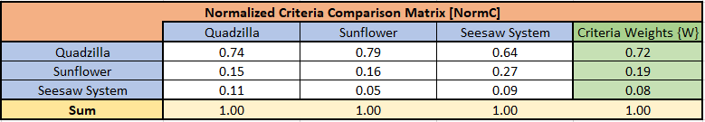
Table 15 Normalized Criteria Comparison Matrix for Collapsible Volumetric Footprint

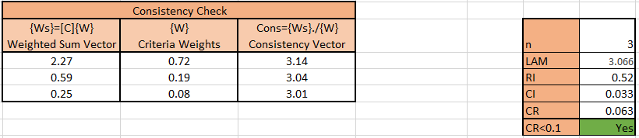
Table 16 Consistency Check for Collapsible Volumetric Footprint

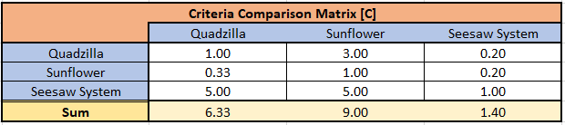
Table 17 Criteria Comparison Matrix for Support 1.4*Max Working Load
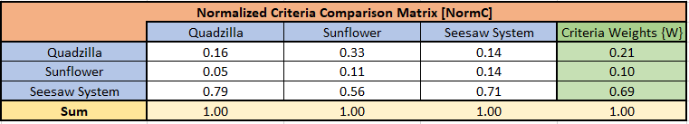
Table 18 Normalized Criteria Comparison Matrix for Support 1.4*Max Working Load
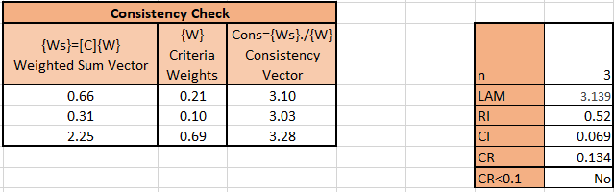
Table 19 Consistency Check for Support 1.4*Max Working Load

Table 20 Criteria Comparison Matrix for Secure Cargo
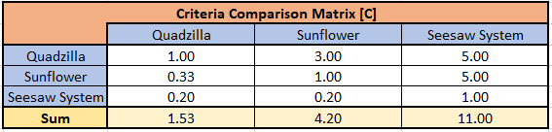
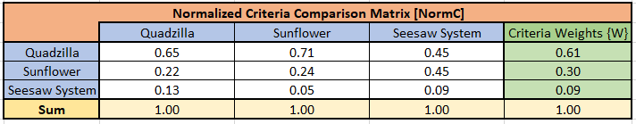
Table 21 Normalized Criteria Compariosn Matrix for Seure Cargo
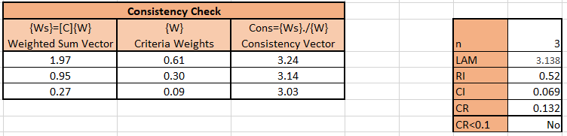
Table 22 Consistency Check for Secure Cargo

Table 23 Criteria Comparison Matrix for Device Stability
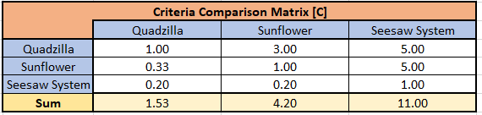

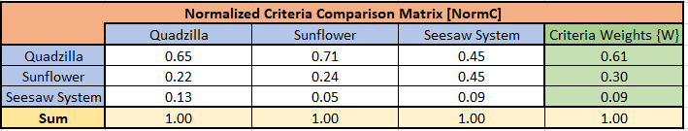
Table 24 Normalized Criteria Comparison Matrix for Device Stability
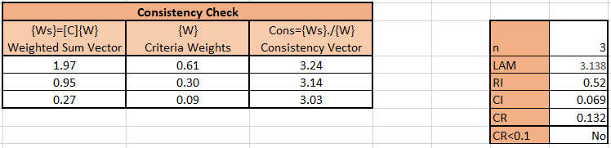
Table 25 Consistency Check for Device Stability

Table 26 Criteria Comparison Matrix for Complete Work Cycle
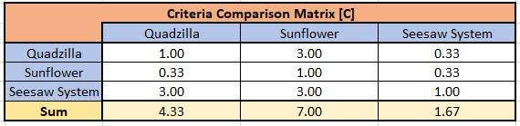
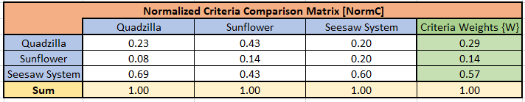
Table 27 Normalized Criteria Comparison Matrix for Complete Work Cycle

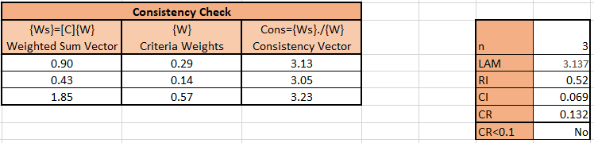
Table 28 Consistency Check for Complete Work Cycle

Table 29 Criteria Comparison Check for Power Source
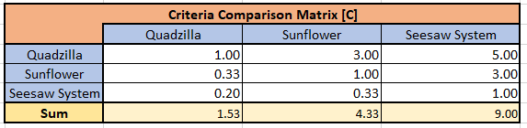

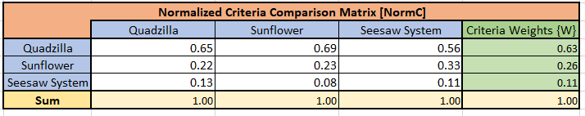
Table 30 Normalized Criteria Comparison Check for Power Source
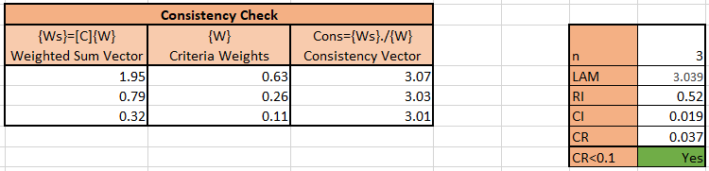
Table 41 Consistency Check for Power Source

Table 32 Criteria Comparison Check for Convert Power to Movement
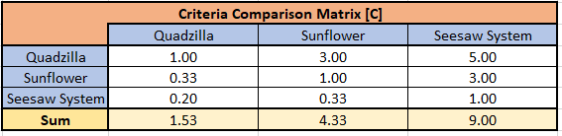

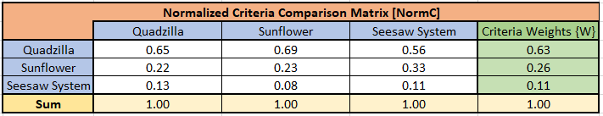
Table 33 Normalized Criteria Comparison Check for Convert Power to Movement
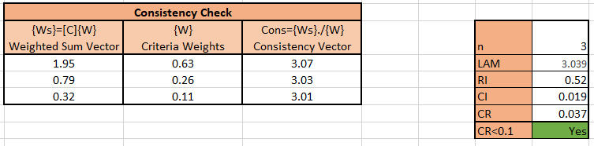
Table 34 Consistency Check for Convert Power to Movement

Table 35 Criteria Comparison Check for Lift Max Weight

Table 36 Normalized Criteria Comparison Check for Lift Max Weight
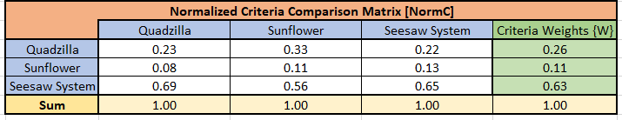

Table 37 Consistency Check for Lift Max Weight
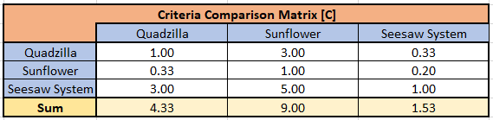
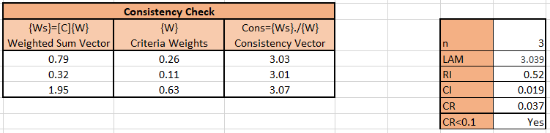

Table 38 Criteria Comparison Check for Ground Clearance
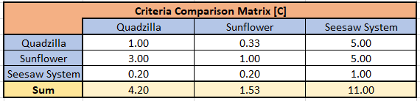
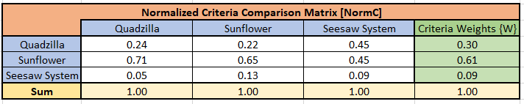
Table 39 Normalized Criteria Comparison Check for Ground Clearance
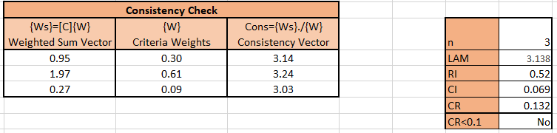
Table 50 Consistency Check for Ground Clearance

Table 41 Criteria Comparison Check for Device Stability over Rough Terrain
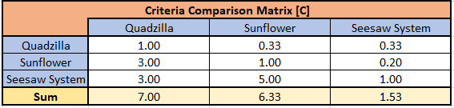

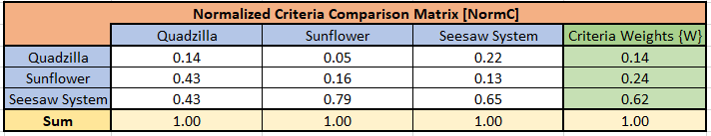
Table 42 Normalized Criteria Comparison Check for Device Stability over Rough Terrain
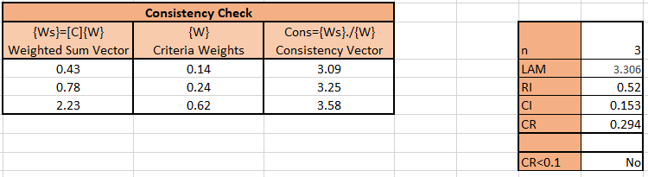
Table 43 Consistency Check for Device Stability over Rough Terrain

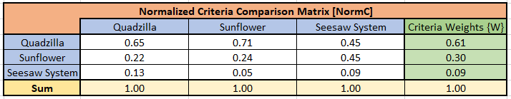
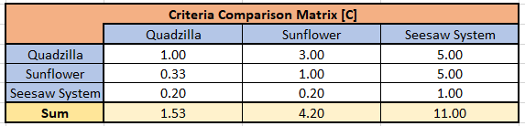
Table 44 Criteria Comparison Matrix for Device Location Feedback
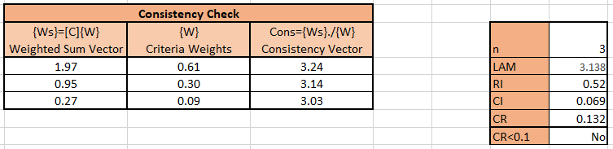
Table 46 Consistency Check for Device Location Feedback
Table 45 Normalized Criteria Comparison Matrix for Device Location Feedback

Table 47 Criteria Comparison Matrix for Stays within Allowable Deviation during Line Following

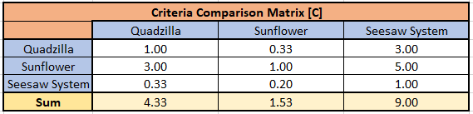

Table 48 Normalized Criteria Comparison Matrix for Stays within Allowable Deviation during Line Following

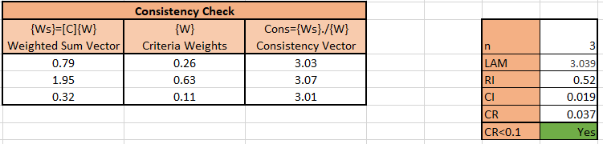
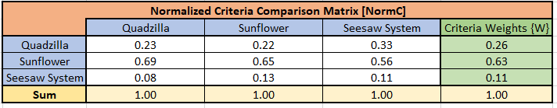
Table 49 Consistency Check for Stays within Allowable Deviation during Line Following

Table 50 Criteria Comparison Matrix for Moves at Desirable Speed

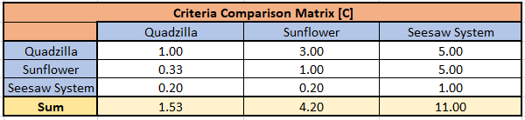

Table 61 Normalized Criteria Comparison Matrix for Moves at Desirable Speed

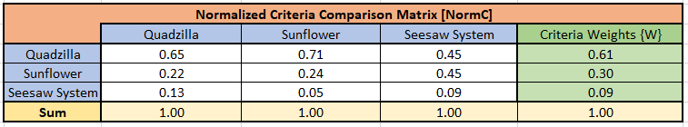

Table 52 Consistency Check for Moves at Desirable Speed

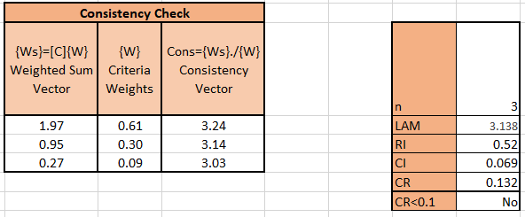
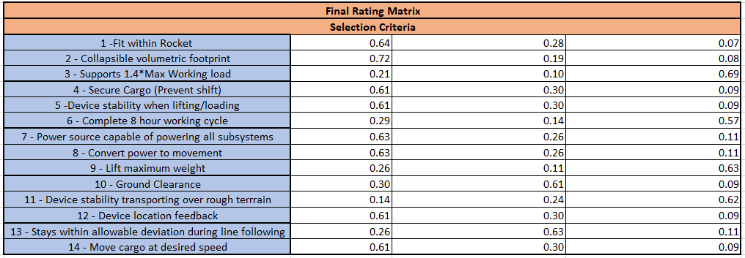
Table 53 Final Rating Matrix

Table 54 Alternative Value Chart

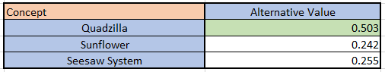

Appendix F: Work Breakdown Structure
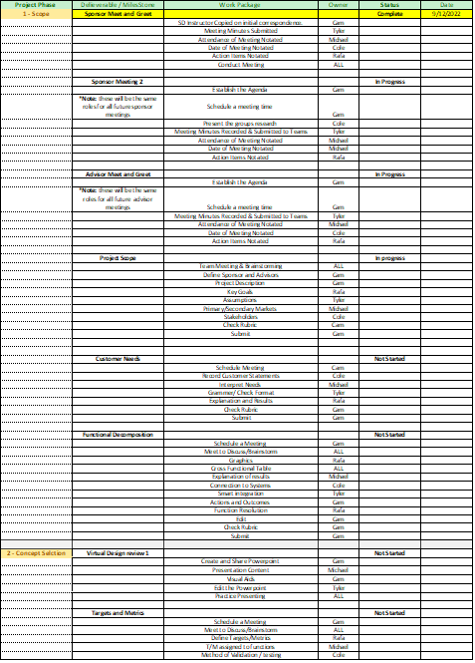

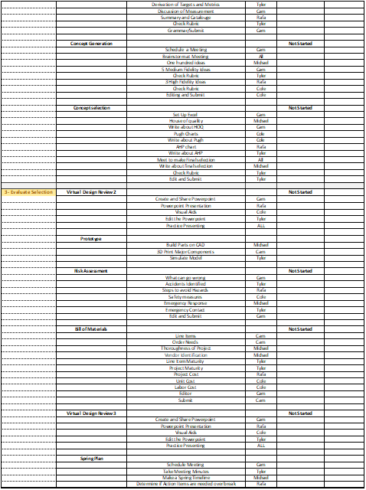

References
There are no sources in the current document.

